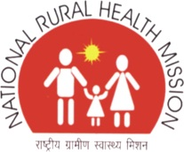
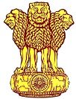

INTENSIFIED DIARRHOEA CONTROL FORTNIGHT
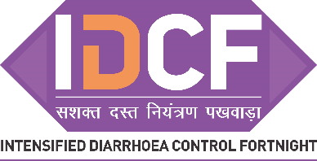

TOOL KIT

Contains:

TRAINING GUIDE

Child Health Division
Ministry of Health & Family Welfare

May 2017

SESSION PLAN FOR OF ONE DAY TRAINING ON IDCF

Time | KEY ASPECTS TO BE COVERED
9.00A.M.-10.30A.M. | Role CLARITY OF ANM/ASHA/AWW ON IDCF
10.30 A.M. | TEA BREAK
11.00A.M.-1.00 P.M. | TECHNICAL SESSION ON DIARRHOEA MANGEMENT.  The session must lead to:  - ANM/ASHA aware and competent on detection of dehydration  - ANM/ASHA are able to choose Plan A/B/C for management of dehydration in children  - ANM/ASHA aware of dosage of ORS/zinc for childhood diarrhea management  - ANM/ASH are aware of key information for prevention of diarrhoea  - ANM/ASHA are aware of nutritional messages during diarrhoea
1.00 P.M. – 2.00 P.M. | Lunch
2.00 p.m. – 3.00 P.M. | How to conduct IDCF VHNSC session
3:00 p.m – 4.00 pm | Familiarization with recording and reporting formats

Diarrhoea is a very common problem in the children under five. Diarrhoea can be serious – and even lead to death.

TRAINING OBJECTIVES
After training, ASHA, ANM and Medical Officers will be able to:

✔ How diarrhea is transmitted
✔ Protect Prevent and Treat approaches to diarrhea control
✔ Define the types of diarrhoea and levels of dehydration
✔ Recognize clinical signs of dehydration
✔ Assess diarrhoea in sick children
✔ Assess dehydration in young infants and sick children
✔ Classify diarrhoea and severity of dehydration using standard charts
✔ Treat using Plans A, B, and C for dehydration
✔ Counsel the caregiver about home treatment for diarrhea
✔ Build skill on how to conduct VHSNC session

KNOWLEDGE TEST

Circle the best answer for each question.

How can diarrhoea kill children? | - Children lose valuable fluids, salts, and sugars, which can cause shock to vital organs  - Children lose valuable nutrients because they cannot eat  - Diarrhoea causes liver failure
What are critical treatments for children with diarrhoea and dehydration? | - Oral antibiotics  - Oral rehydration therapy and Zinc  - Paracetamol for discomfort
What is persistent diarrhoea? | - When a child frequently has diarrhoea over a period of 1 month, and is ill as a result  - When a child has several episodes of diarrhoea in a day  - When a child has an episode of diarrhoea lasting 14 days or more, which is particularly dangerous for dehydration and malnutrition
Critical messages for caregivers about diarrhoea and dehydration include: | - The child must receive increased fluids, ORS, Zinc, and regular feeding  - The child requires ORS, but should receive less food in order to reduce the diarrhoea  - The child should immediately receive antibiotics to stop the diarrhoea
Rani arrives at your health facility and is very lethargic. Her eyes are very sunken. She has diarrhoea. You observe a significant loss of skin elasticity. How will you manage Rani? | - Rani requires ORS immediately, as she is dehydrated.  - These are common signs of diarrhoea, as the child’s body is exhausted.  - Rani is severely dehydrated. She requires urgent rehydration therapy by IV or nasogastric tube.
What could have been done by Rani’s mother earlier to prevent diarrhoea | a. The mother and Rani should be washing hands with soap at critical times – before making/eating food and after using toilet, after cleaning feces of the baby.  b. Maintain hygiene and sanitation in the village.  c. Wash utensils before cooking food
What role can be played by village health and sanitation committee in diarrhoea prevention and protection? | a. Maintain hygiene and sanitation in the village.  b. Organise meetings with health workers and Anganwadi worker.  c. Organise special meetings to talk to people about cleanliness

CHILDHOOD DIARRHOEA AND ‘PROTECT, PREVENT & TREAT’ APPROACHES TOWARDS ITS CONTROL’

- WHAT IS DIARRHOEA?

Diarrhoea is considered when stools have changed from usual patter and are many & watery (more water than fecal matter). It is more common in settings of poor sanitation and hygiene, including a lack of safe drinking water.
Most diarrhoea that causes dehydration is loose or watery.

The normal frequent or loose stool of a breast fed baby are not diarrhea.

- WHAT ARE THE TYPES OF DIARHOEA IN CHILDREN

Type of Diarrhoea | Definition
ACUTE DIARRHOEA | Is an episode of diarrhoea that lasts less than 14 days. Acute watery diarrhoea causes dehydration and contributes to malnutrition. The death of a child with acute diarrhoea is usually due to dehydration
PERSISTENT DIARRHOEA | If an episode of diarrhoea that lasts for 14 days or more. [Up to 20% of episodes of diarrhoea become persistent, and this often causes nutritional problems and contributes to death in children]
DYSENTERY | Diarrhoea with blood in the stool, with or without mucus. The most common cause of dysentery is Shigella bacteria. Amoebic dysentery is not common in young children. A child may have both watery diarrhoea and dysentery.

*for the purpose of health workers any diarrhoea that lasts for more the 14 days should be considered severe persistent diarrhoea and referred to health facility

3. WHAT ARE THE TYPES OF DIARHOEA IN YOUNG CHILDREN INFANTS (0-2 MONTHS AGE)?

A young infant has diarrhoea if the stools have changed from the usual pattern, and are many and watery. This means more water than faecal matter. The normally frequent or semi-solid stools of a breastfed baby are not diarrhoea.

- TRANSMISSION OF DIARRHOEA INFECTION

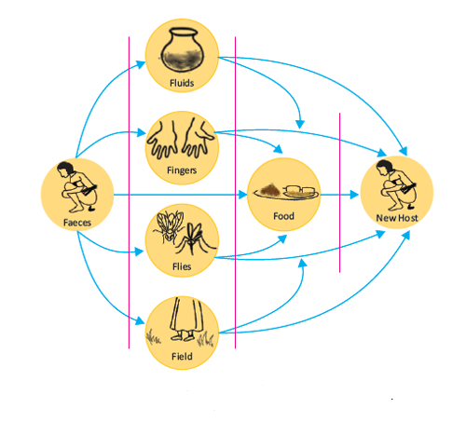
Diarhoeal infection is majorly transmitted through the of faecal-oral diseases. The adjactent ‘F-diagram’ illustrates the different routes that the microbes of diarrhoea take from faeces, through the environment, to a new person. For example; microbes in faeces on the ground by a well can get into the water system and be drunk by a child, hands that have not been washed after going to the toilet can carry microbes onto foods, which are then eaten, infecting another child, who gets diarrhoea and spreads more microbes.
Disuss the F diargram.
- ‘PROTECT, PREVENT AND TREAT’ APPROACHES FOR CHILDHOOD DIARRHOEA CONTROL

Children can be protected against infections, prevented from getting diarrhea and treated for diarrhea. Thus the approaches for childhood diarrhea control are (i) protection, (ii) prevention and (iii) treatment. The various interventions under these approaches are as follows:

Protect approaches | Prevent approaches | Treat approaches
Exclusive breast feeding  Complementary feeding  Vitamin A supplementation | Immunization  - Measles vaccine  - Rota-virus vaccine  Handwashing with soap  Using toilets for defecation  Prevention of HIV | ORS  Zinc  Continued feeding

For the control of diarhoea, ‘Protect, Prevent and Treat (PPT) interventions’ are very essential. You would have learnt of the protect and prevent interventions in detail in previous training. This training module covers the treat interventions in detail.
It is important that every childhood diarrhea case should be assessed for the classification of dehydration so that appropriate treatment is administered.

- WHAT IS DEHYRDATION?

Diarrhoea can be a serious problem – and even lead to death – if child becomes dehydrated. Dehydration is when the child loses too much water and salt from the body. This causes a disturbance of electrolytes, which can affect vital organs.

A child who is dehydrated must be treated to help restore the balance of water and salt. Many cases of diarrhoea can be treated with Oral Rehydration Salts (ORS), a mixture of glucose and several salts. ORS and extra fluids can be used as home treatment to prevent dehydration.

HOW TO ASSESS DEHYDRATION?
There are several signs that help to decide the severity of dehydration. When a child becomes dehydrated, s/he is at first restless or irritable. As the body loses fluids, the eyes may look sunken, and skin loses elasticity. If dehydration continues, the child becomes lethargic or unconscious.

LOOK: AT THE CHLD’S GENERAL CONDITION

When you check for general danger signs, you check to see if the child was lethargic or unconscious. If the child is lethargic or unconscious, he has a general danger sign. Remember to use this general danger sign when you classify the child’s diarrhoea.

A child is classified as restless and irritable if s/he is restless and irritable all the time or every time s/he is touched and handled. If an infant or child is calm when breastfeeding but again restless and irritable when s/he stops breastfeeding, s/he has the sign restless and irritable. Many children are upset just because they are in the health facility. Usually these children can be consoled and calmed, and do not have this sign.
FOR THE YOUNG INFANT: watch the infant’s movement. Does s/he move on his / her own? Does the infant only move when stimulated, but then stops? Is the infant restless and irritable?

LOOK: FOR SUNKEN EYES

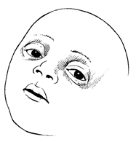
The eyes of a child who is dehydrated may look sunken. Decide if you think the eyes are sunken. Then ask the mother if she thinks her child’s eyes look unusual. Her opinion can help you confirm. NOTE: In a severely malnourished child who is wasted, the eyes may always look sunken, even if the child is not dehydrated. Still use the sign to classify dehydration.

LOOK: TO SEE HOW THE CHILD DRINKS

Ask the mother to offer the child some water in a cup or spoon. Watch the child drink.
- A child is not able to drink if s/he is not able to suck or swallow when offered a drink. A child may not be able to drink because he is lethargic or unconscious.
- A child is drinking poorly if the child is weak and cannot drink without help. S/he may be able to swallow only if fluid is put in his / her mouth.
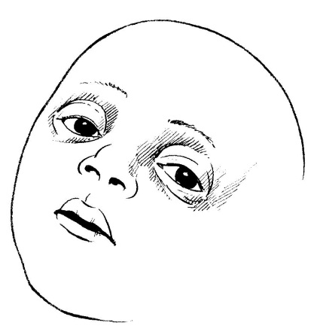
- A child has the sign drinking eagerly and acts thirsty if it is clear that the child wants to drink. Look to see if the child reaches out for the cup or spoon when you offer him / her water. When the water is taken away, see if the child is unhappy because s/he wants to drink more. If the child takes a drink only with encouragement and does not want to drink more, s/he does not have the sign drinking eagerly, thirsty.
FEEL: BY PINCHING THE SKIN OF THE ABDOMEN

This skin pinch tests is an important tool for testing dehydration. When a child is dehydrated, the skin loses elasticity. To assess dehydration using the skin pinch:

- ASK the mother to place the child on the examining table so that the child is flat on his / her back with his / her arms at his / her sides (not over his / her head) and his / her legs straight. Or, ask the mother to hold the child so s/he is lying flat on his/her lap.
- USE YOUR THUMB AND FIRST FINGER to locate the area on the child’s abdomen halfway between the umbilicus and the side of the abdomen. Do not use your fingertips because this will cause pain. The fold of the skin should be in a line up and down the child’s body.
- PICK UP all the layers of skin and the tissue underneath them.
- HOLD the pinch for one second. Then release it.
- LOOK to see if the skin pinch goes back very slowly (more than 2 seconds), slowly, (less than 2 seconds, but not immediately), or immediately. If the skin stays up for even a brief time after you release it, decide that the skin pinch goes back slowly. The photographs below show you how to do the skin pinch test and what the skin looks like when the pinch does not go back immediately.
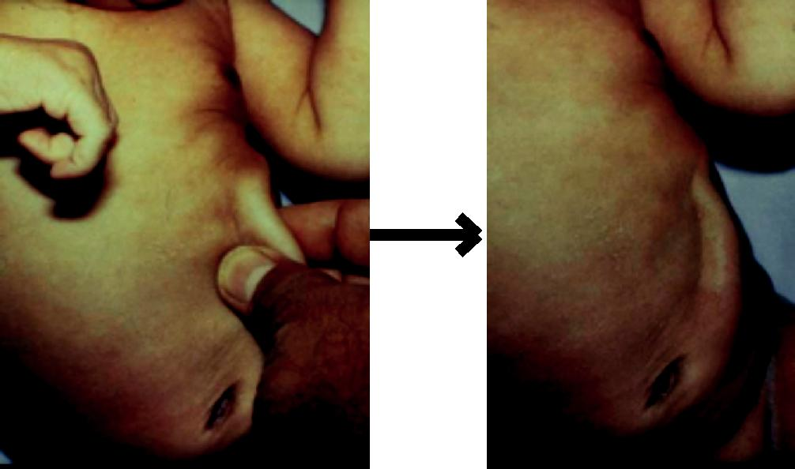

Skin pinch Skin pinch going back very slowly
NOTE: The skin pinch test is not always an accurate sign. In a child with severe malnutrition, the skin may go back slowly even if the child is not dehydrated. If a child is overweight or has edema, the skin may go back immediately even if the child is dehydrated. However you should still use it to classify the child’s dehydration.

7. HOW TO CLASSIFY DEHYDRATION?

There are three possible classifications for the type of diarrhoea. These are:

- SEVERE DEHYRDATION (RED)

Classify as SEVERE DEHYDRATION if the child has two or more of the following signs: lethargic or unconscious, not able to drink or drinking poorly, sunken eyes, or very slow skin pinch.
ACTION
Any child with dehydration needs extra fluids. A child classified with SEVERE DEHYDRATION needs fluids quickly. Treat with IV (intravenous) fluids. “Plan C: Treat Severe Dehydration Quickly” describes how to give fluids to severely dehydrated children.

- SOME DEHYDRATION (YELLOW)

Classify as SOME DEHYDRATION if the child has two or more of the following signs: restless and irritable; drinks eagerly (not in children less than two months age); sunken eyes; or skin pinch goes back slowly.
ACTION

A child who has SOME DEHYDRATION needs ORS, foods and Zinc supplements. Treat the child with ORS solution and Zn supplementation. In addition to fluid, the child with SOME DEHYDRATION needs food. Breastfed children should continue breastfeeding. Other children should receive their usual milk or some nutritious food after 4 hours of treatment with ORS. The treatment is described in the box “Plan B: Treat Some Dehydration with ORS”. One will learn more about ORS and zinc supplements in the next section.

3. NO DEHYRDATION (GREEN)

A child who does not have two or more signs in the red or yellow row is classified as having NO DEHYDRATION. This child needs extra fluid and foods to prevent dehydration.

The four rules of home treatment are:

- Give extra fluid

- Give Zinc supplements

- Continue feeding

- Return immediately if the child develops danger signs, drinks poorly, or has blood in stool
ACTION

The treatment box called “Plan A: Treat Diarrhoea At Home” describes what fluids to teach the mother to give and how much she should give. A child with NO DEHYDRATION also needs food and zinc supplements. You will learn more about Plan A and Zinc in the next section.
After classifying dehydration, classify the child for persistent diarrhoea if the child has had diarrhoea for 14 days or more. Then classify for dysentery.

8. HOW TO CLASSIF AND MANAGE CHILDREN WITH DIARHOEA ?
CHART 1: DIARRHOEA ASSESS, CLASSIFY AND MANAGEMENT PROTOCOL FOR CHILDREN (> 2 months to 5 years)
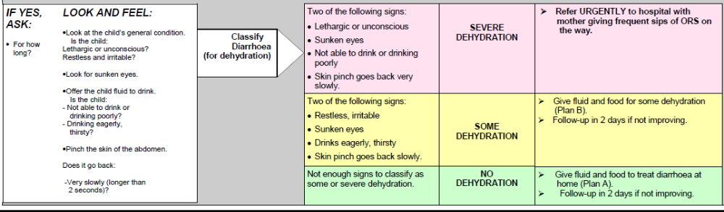

CHART 2: DIARRHOEA ASSESS, CLASSIFY AND MANAGEMENT PROTOCOL FOR YOUNG INFANT(<2 months age)
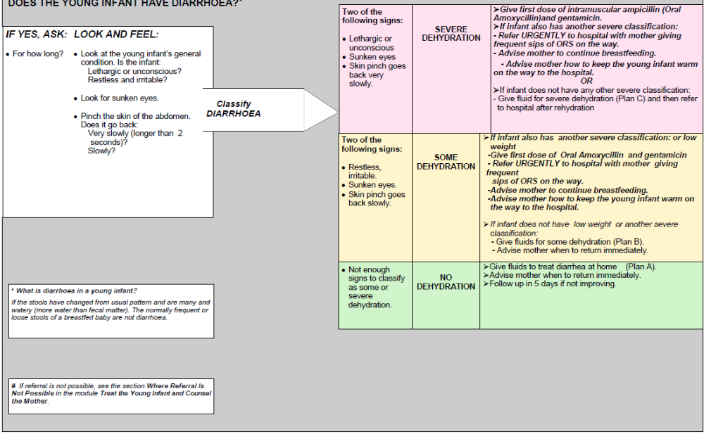
(by ANM)
- Refer to hospital for Plan (C) for IV rehydration
(by ANM)
9. HOW TO TREAT THE CHILD WITH DIARRHOEA

WHAT TREATMENTS ARE IDENTIFIED FOR DIARRHOEA AND
DEHYDRATION?

The color-coded classifications also indicate where the treatment can be delivered –
by urgent referral, at the health facility, or at home.

Identified treatments are listed below.

✔Plans A, B, and C for giving fluids and food

✔Giving ORS for dehydration

✔Zinc supplementation

What are the key steps for management of diarrhea in children?

4 KEY INTERVENTIONS FOR CHILDHOOD DIARHOEA MANAGEMENT
- Rehydrate the child with ORS solution
- in case of no-dehydration follow Plan A at home,

administer ORS to prevent dehydration
- in case of some dehydration follow Plan B at

health facility level, administer ORS to rehydrate
- In case of severe dehydration follow Plan C by use

of IV fluids at health facility.
- Administer Zinc dispersible tablets for 14 days,

even after diarrhoea stops.
- Continued age appropriate feeding.
- Rational use of antibiotics

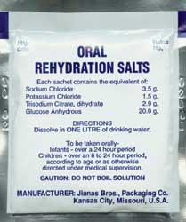

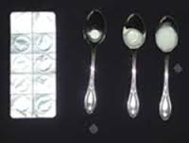

=

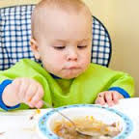

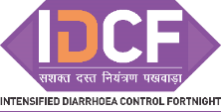
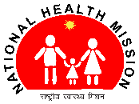
TREATMENT FOR DIARHOEA WITH NO DEHYDRATION
AT HOME (PLAN A)
IN CHLDREN UPTO 5 YEARS AGE

- GIVE EXTRA FLUID (as much as the child will take)

TELL THE MOTHER

If child is less than 6 months age | If child is more than 6 months age
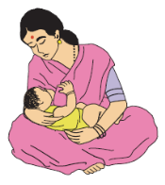  Breastfeeding frequently and  for longer + ORS | Give home fluids + ORS  Yoghurt drink, milk, lemon drink, rice or pulses- based drink, vegetable soup, green coconut water or plain clean water.  If child is breastfeeding then continue it.

Teach the mother how to prepare and give ORS solution. Give the mother 2 packets of ORS to use at home.

SHOW THE MOTHER HOW MUCH FLUID TO GIVE IN ADDITION TO THE USUAL FLUID INTAKE

Upto 2 months | 2 months upto 2 years | 2 years or more
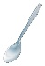  5 tea spoons after each loose stool | 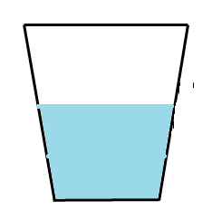  1/4 glass to 1/2 glass (50 – 100 ml) after each loose stool. |   1/2 cup to 1 cup (100 – 200 ml) after each loose stool

Tell the mother to:
- Give frequent small sips from a cup.
- If the child vomits, wait 10 minutes. Then continue, but more slowly.
- Continue giving extra fluid until the diarrhoea stops.

2. GIVE ZINC SUPPLEMENTS FOR 14 DAYS

Age | Dose
2 – 6 months | 10 mg (half tablet) in breast milk in spoon
6 months – 5 years | 20 mg (one tablet) for 14 days in clean water in spoon

Teach the mother how to prepare Zinc supplements
Give one dose of Zinc in front of the mother

3. ADVICE CONTINUE FEEDING, HAND WASHING AND TOILET USE

4. INFORM WHEN TO RETURN
➢Child becomes sicker
➢Not able to drink or breastfeed ➢Blood in stool
➢Drinking poorly ➢Develops a fever

Display this treatment protocol in every ORS and Zinc corner, pediatric OPD, and pediatric ward.

TEACH THE CARE GIVER TO PREPARE ORS
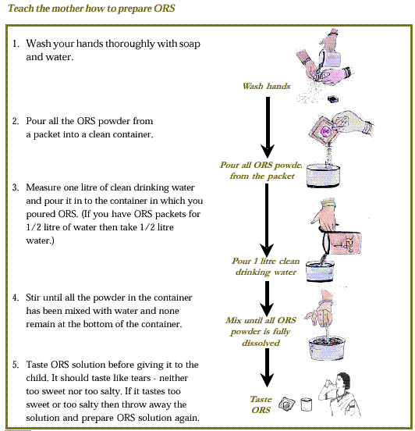

Ask the mother to give one teaspoon of the solution to the child. This should be repeated every 1-2 minutes (An older child who can drink it in sips should be given one sip every 1-2 minutes).

If the child vomits the ORS tell the mother to wait for 10 minutes and resume giving the ORS but this time more slowly than before. Breast fed babies should be continued to be given breast milk in between ORS. Any ORS which is left over after 24 hours should be thrown away.

TEACH THE CARE GIVER TO PREPARE ZINC SOLUTION

- Remove one tablet of Zinc (20 mg) from the blister pack.

- If Zinc is to be administered to children 2 – 6 months age
  - then break the tablet into half (i.e 10 mg). The tablet can be broken at the division line. Discard the remaining half.
  - Take a clean tea spoon.
  - Request the mother to express milk from her breast into the spoon and then add ½ tablet.

- If Zinc is to be administered to children 6 months to 5 years age,
  - there is no need to break the tablet as dose for these children is full tablet (20 mg)
  - Take a clean tea spoon, place one tablet in the spoon
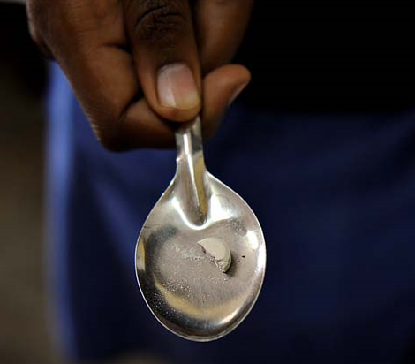
  - Pour potable water carefully on the tablet taking care that the water does not reach the brim of the spoon.

- Shake the spoon slowly till the tablet dissolves
completely. Do not use fingertip or any material
to dissolve the tablet.

- Tell the mother to hold the child comfortably and
ask her to feed the solution to the child.

- If there is any powder remaining in the spoon, let the child lick or add little more breast milk or water to dissolve it and then ask the mother to give it again.

- Counsel the mother to administer Zinc for once a day for total of 14 days.

HANDWASHING WITH SOAP AT CRITICAL TIMES – STEPS IN HANDWASHING

Proper hand washing means washing your hands for at least 30 seconds with soap and water. The constant rubbing action helps soap break down the grease and dirt that carry most germs. This way, your hands don’t just smell fresh, but you’ll also reduce the germ count on your hands by up to 99 percent.

Follow these 8 steps to clean hands:
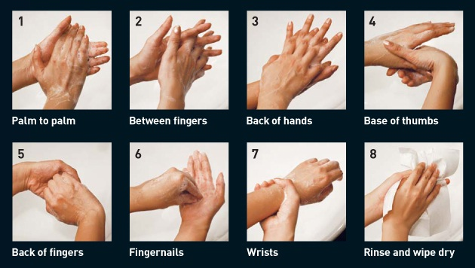

When to wash your hands

Make sure you wash your hands whenever you do the following:
Before | After
Handling or preparing food  Eating meals  Attending to a child or sick person  Feeding a child | Using the toilet  Wiping or blowing your nose  Coughing and sneezing  Changing baby’s diapers.

TREATMENT FOR DIARHOEA WITH SOME DEHYDRATION
AT HEALTH FACILITY / ORS – ZINC CORNER (PLAN B)
IN CHLDREN UPTO 5 YEARS AGE

Child with diarrhea with some dehydration has any of the two signs:
- Restless, irritable
- Sunken eyes
- Drinks eagerly, thirsty (do not assess in child less than 2 months age)
- Skin pinch goes back slowly

1. GIVE ORS FOR 4 HOURS
AGE* | Up to 4 months | 4 months up to  12 months | 12 months up to  2 years | 2 years up to  5 years
WEIGHT | < 6 kg | 6 - < 10 kg | 10 - < 12 kg | 12 - 19 kg
QUANTITY  OF ORS | 1 – 2 glass  (200 – 400 ml) | 2 – 3 glass  (400 – 700 ml) | 3 – 4 glass  (700 – 900 ml) | 4 – 7 glass  (900 – 1400 ml)  ml)

* Use the child’s age only when you do not know the weight. The approximate amount of ORS required (in ml) can also be calculated by multiplying the child’s weight (in kg) times 75.

• If the child wants more ORS than shown, give more.
• For infants under 6 months who are not breastfed, also give 100-200 ml clean water during this period.

➢ SHOW THE MOTHER HOW TO GIVE ORS SOLUTION.
• Give frequent small sips from a cup.
• If the child vomits, wait for 10 minutes. Then continue, but more slowly.
• Continue breastfeeding whenever the child wants.

- AFTER 4 HOURS:
• Reassess the child and classify the child for dehydration.
If No dehydration | Then shift the child to Plan A, home based treatment  - ORS  - Zinc tablet for 14 days  - Continued feeding  - Advice when to return | Teach the mother how to mix and give ORS and Zinc  Give one dose of Zinc in front of the mother  Give mother 2 packets of ORS and 14 days Zinc course to use at home.  Advise on continued feeding, handwashing and toilet use
If Severe dehydration | Then refer the child for admission for Plan C, IV based treatment  On the way, advice the mother to give frequent sips of ORS  If child is less than 2 months age then the ANM should give first dose of intramuscular Ampicillin / oral Amoxicillin and Injection Gentamycin before referral.

Display this treatment protocol in every ORS and Zinc corner, OPD, and ward where children with diarrhea are admitted.
PLAN C FOR TREATMENT OF SEVERE DEHYDRATION

Severely dehydrated children and young infants need to have water and salts quickly replaced. Plan C requires rapid hydration using IV fluids or a nasogastric (NG) tube. It is important to note that rehydration therapy using IV fluids or using a nasogastric (NG) tube is recommended only for children who have SEVERE DEHYDRATION.

WHERE IS PLAN C GIVEN?

Health facility, where is the safest place to give plan c?
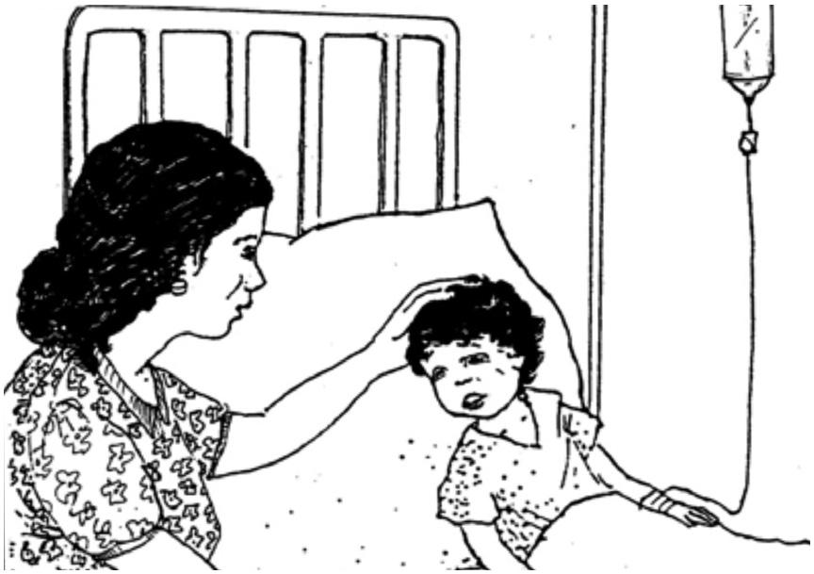
This is important for you to determine based on available equipment and your training. If you cannot give IV or NG fluid and the child cannot drink, refer the child urgently to the nearest hospital that can give IV or NG treatment.

If IV (intravenous) treatment is available within a 30-minute drive, refer urgently to hospital for treatment with IV fluids. On the way to hospital, have the mother offer frequent sips of ORS to her sick child.

Plan C should only be provided in the health facility and administered by Medical Officer to manage severely dehydrated children and young infants

In this module, the treatment through IV fluids is described. Do not teach Plan C to field level health workers (ASHA and ANM).

TREATMENT FOR DIARHOEA WITH SEVERE DEHYDRATION
IN WARD (PLAN C)
IN CHLDREN UPTO 5 YEARS AGE

Child with diarrhea with severe dehydration has any of the two signs:
- Lethargic or unconscious
- Sunken eyes
- Skin pinch goes back very slowly

- START IV FLUID IMMEDIATELY.
  - If the child can drink give ORS by mouth till the drip is being set up. Give 100 ml / kg Ringer’s Lactate Solution (or, if not available, normal saline), divided as follows:

AGE | First give  30 ml / kg in | Then give  70 ml / kg in
Infants (under 12 months) | 1 hour * | 5 hours
Children (12 months – 5 years) | 30 minutes* | 2 ½ hours

  - Repeat once if radial pulse is still very weak and not detectable

  - Reassess the child every 15-20 minutes till a strong radial pulse is detectable. Thereafter reassess the hydration status after every 1-2 hours. If hydration status is not improving, give IV drip more rapidly. Monitor number of stools, vomiting and urine output.

- ALSO GIVE ORS (5ml/kg/hour) as soon as the child can drink; usually after 3-4 hours (infant) or 1-2 hours (children)

- REASSESS an infant after 6 hours and a child after 3 hours. Classify dehydration. Then choose the appropriate plan (A, B or C) to continue treatment.

- OBSERVE SIGNS OF OVER HYDRATION (sudden increase in respiratory rate, chest retractions, heart rate appearance of crepitation in chest, increase in liver span) throughout IV rehydration.

WHEN TO SEND CHILD HOME?
- Hydration is maintained for 6 hours on ORS after rehydration.

WHEN SENDING HOME
- Teach the mother how to prepare solutions of ORS and Zinc
- Provide atleast 2 packets of ORS and Zinc tablets for 14 days course
- Administer a dose of Zinc as follows:
  - 2 – 6 months : 10 mg (1/2 tablet)in breast milk in spoon
  - 6 months to 5 years: 20 mg ( one tablet) in clean water in spoon
- Counsel on continued feeding, handwashing and toilet use

Display this treatment protocol in every ward where children with diarrhea are admitted.

WHAT IS THE FEEDING ADVICE TO BE GIVEN DURING DIARRHOEA?
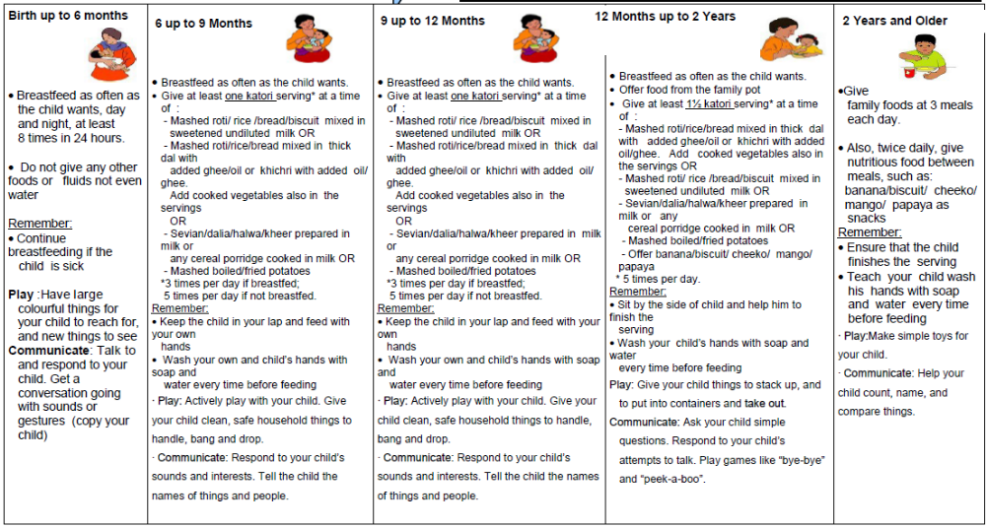

REFER CHILDREN URGENTLY TO THE HOSPITAL IN FOLLOWING CONDITIONS

- Child passing blood in stools
- Severe dehydration
- Not able to drink or breastfeed
- Vomits everything
- Convulsions
- Lethargic or unconscious
- Cough or difficult breathing and fast breathing or ‘pneumonia’ or ‘paslichalna’
- Other associated illness
- Severe malnutrition
- If diarrhea more than 14 days

WHAT ARE THE COMMON LOCAL MISCONCEPTIONS WITH PEOPLE THAT NEEDS TO BE REJECTED BY ALL?

- ORS should not to be given in winter even when the child has diarrhea
- ORS should be given in summer even when the child does not have diarrhea. In such cases, if you feel that due to heat child needs extra fluid, give shikanji, lassi and other fluids at home.
- Some foods should be reduced in diarrhea
- Feeding during diarrhea will worsen the case.
- Breastfeeding should be reduced in diarrhea
- Diarrhea due to extremes of weather, evil spirits (uprihawa) or indigestion does not need any treatment

SET UP OF ORS – ZINC CORNER

ORS - Zinc Corners are usually meant for childhood diarrhoea with some dehydration to be administered ORS under supervision for 4 hours. Also no-dehydration cases that come directly to facilities could be treated at the ORS – Zinc corners. When there are no diarrhoea cases using the ORS – Zinc corner, the area can be used for treating other problems

Location:
ORS – Zinc corners should be permanently at health facilities like Medical Colleges, District Hospitals, Block health facilities, primary health centres, sub-centres, private paediatrics facilities etc. Earmark a suitable area in the health facility for the corner. A small corner in the OPD or ward or any other suitable area in the health facility is generally enough for this purpose. The space required would depend on the case load. While earmarking such an area it should be ensured that:
- In case of hospital, the area is close to the workplace of the Doctor so that assessment of the child can be carried out frequently.
- The area is near a toilet or a washing facility, where mothers can clean the child and wash their hands before feeding them.
- Mothers can sit comfortably while administering ORS to their child.
- Pleasant and well-ventilated.

Timings:
The ORS – Zinc corners should be functional during OPD timings and 24 hours in paediatrics ward. A health worker who is trained in preparation of ORS solution and Zinc solution, should be posted to manage the corner. The corner should be prominently labeled as “ORS – Zinc Corner for treatment of diarrhoea”

Materials required for management of ORS – Zinc corner
- One table and two chairs / one bench with a back where the mother can sit comfortably while holding the child should constitute the corner
- Shelves to hold supplies
- Sufficient ORS packets and Zinc tablets with potable drinking water in a clean container, five glasses (200 ml), bowl / cup, soap, waste-backet, one litre vessel, clean spoons and leaflets should be on the table.
Counselling at the ORS – Zinc corners:
- The doctor / staff should counsel the mother in person using MCP card and administration of Zinc for 14 days.
- ORS – Zinc corner is a good place to display informative materials. Banner and poster on ORS – Zinc, hand washing and continued feeding should be displayed at the corner.
Activities:
- At least one litter of ORS solution should be prepared daily after washing hands with soap and water. The solution should be kept at the ORS – Zinc corner. It should be readily available to the mother when required. Replenish the solution whenever required. More than 24 hours prepared solution should be discarded and not be used. After the mother has washed her hands thoroughly with soap and water, provide the ORS solution in bowl / cup or glass with spoon to enable her to administer the solution.
- In case of a diarrheal episode during ORS administration, the child and mother and the area should be thoroughly cleaned. After washing hands again with soap and water the mother should administer ORS.
- If the child vomits, the child and mother and the area should be thoroughly cleaned. After washing hands again with soap and water the mother should administer ORS more slowly.
- In case of no-dehydration diarrhoea,
  - Administer ORS solution at the corner for some time till the child is comfortable.
  - Explain the mother on how to prepare the ORS solution, if possible demonstrate.
  - Demonstrate on how to prepare age appropriate Zinc tablet solution in a spoon.
  - Administer the first dose of Zinc tablet solution.
  - Explain when to administer ORS and Zinc.
  - Provide at least one ORS packet and 13 tablets of Zinc to take home.
  - Advice on age appropriate feeding during diarrhoea
  - Advice when to return
- In case of some-dehydration diarrhoea,
  - Administer ORS solution at the corner for 4 hours
  - Re-asses the child for status of dehydration.
  - In case of no dehydration, follow the above steps for no-dehydration diarrhoea.
  - In case of severe-dehydration, the child needs to be admitted for Plan C treatment.

10. VHNSC MEETING FOCUSING ON SWACCH BHARAT ABHIYAN

VHNSC meeting in the village will be on the same day of ORS distribution activity in that village, i.e. on the day of ANM visit. The VHNSC will focus on improving sanitation in and around the village. PLA (Participatory Learning Approach) techniques should be carried out such as mapping of open defecation areas in and surrounding the village and plan for stopping open defecation should be chalked out, with active participation of VHSNC members and representatives from Department of Drinking Water and Sanitation.
- The ASHA / ANM will ask the participants to narrate the ailments caused due to water contamination. This could be Diarrhea, Typhoid, Intestinal worms, Abdominal pains, Vomiting etc.

- The ASHA / ANM will ask participants to narrate what contaminates the water to cause these diseases. A relationship between human faeces, water and the diseases will be established. Focus on how faecal matter slowly recedes into the soil and not She will explain how contaminated human faeces get into water and food from open defecation through flies.

- The ASHA / ANM will ask one of the participant’s who had suffered from Diarrhea, about the suffering and cost involved for treatment.

- A calculation of quantity of faeces will be done. For this The ASHA / ANM will ask the participants the average percentage of households that do not have a toilet.

- Average percentage of households that do not have toilet X Total population of the village = No. of people defecating in the open.

- No. of people defecating in the open. X 0.3 kg (average faeces excreted per person per day) = Daily quantity of faeces excreted in open (in kg).

- Daily quantity of faeces excreted X 30 = Monthly quantity of faeces excreted in open (in kg).

- Monthly quantity of faeces excreted per day X 12 = Annual quantity of faeces excreted in open (in kg).

- The importance of use of toilet for defecation will be emphasized.

- A rough map of the village will be drawn on the ground using a stick or stone.

- Geographical areas within the village and it’s vicinity that are used for open defecation (i.e. toilets not used for defecation) will be marked in the map. She will explain how contaminated human faeces get into water and food from open defecation through flies.

- The ASHA / ANM will ask the participants what should be done so that there is no one who suffers from diarrhea.

- The ASHA / ANM will ask on what can VHNSC members do so that no one suffers from diarrhea – prod on handwashing with soap, safe drinking water and use of toilets.

- For the above exercise, ASHA may test water from it’s source using the field test kit (H2S vials) that is with the gram panchayats. The result of the test is available in 24 hours. The result can be declared during the above exercise.
OVERVIEW OF IDCF - 2017

Dates of IDCF: 12-24 June 2017
Goal of IDCF: Attain zero child deaths due to childhood diarrhoea.
Specific objectives of IDCF:
- To improve usage of ORS and Zinc for childhood diarrhoea.
- To complement awareness activities (including Swachh) for prevention and management of diarrhoea in under-five children.

How many children die due to childhood diarrhea in India?
Around 1.2 lakhs children die due to diarrhoea annually in the country. Diarrhoeal deaths are usually clustered in summer and monsoon months and the worst affected are children from poor socio-economic situations.
Activities during IDCF
At community / village level
- Distribution of ORS in households of under-five children and demonstration (by ASHA and mobile teams)
- IPC activities by ANM on hygiene and sanitation along with management of diarrhoea
- Handwashing demonstration in schools
- Mobile health teams for urban areas

At health facility level
- Establishment of ORS and Zinc corners for treatment of diarrhoea
- Promote standard case management of diarrhoeal cases
- Cleaning of water tanks in health facilities

Distribution of ORS and demonstration of ORS and Zinc at the community level
- Every ASHA to distribute ORS packets to all families with under five children.
- During the household visit ASHA will deliver key messages to the mothers / families
- A group demonstration for the preparation of the ORS solution will be conducted by ASHA. It will involve gathering of members from 4-8 households and demonstrating the steps for preparation of ORS solution and Zinc solution. Understanding of the caregivers must be checked after the demonstration.
- ASHAs will also educate families on the importance of hygiene and sanitation.
- ASHA will undertake identification and referral of diarrhoeal cases to ANM/ health facilities and also educate mothers on the danger signs.
- ASHA will report all diarrhoeal deaths during the fortnight.
- At the end of Fortnight a report will be submitted by ASHA→ANM→BCM (Block DEO will compile the data)→ DCM (DM&E will compile the data)→State Health Society.
- The activity of the village to be monitored by ANMs
Activities by ANM on sanitation & hygiene along with management of diarrhoea.
- During the fortnight, ANM should conduct IDCF meeting in her Sub centre village and VHNDs (as per her existing micro-plan) to disseminate information on prevention & control of diarrhoea, especially involving care givers of under-five children.
- ANM should start the session with key message of the IDCF campaign highlighting importance of ORS and Zinc, continued feeding, hand-washing in control of childhood diarrhoea and use of toilets for defecation.
- ANM should carry out VHNSC meeting focusing on Swacch Bharat Abhiyan.

Hand-washing demonstration in schools
- This activity needs to be carried out in all primary and middle schools.
- Each school should have poster pasted at the hand washing area on steps for effective hand washing.

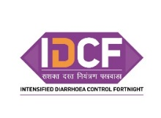
Village level plan for IDCF and implementation checklist
(For ANM)

(MOIC to ensure this format is filled for all sub-centres including vacant sub-centres)
Name of the sub-centre:___________ Block: ___________ Name & Mobile no of ANM:__________
ANM visit plan during IDCF
 | June 12 | June 13 | June 14 | June 15 | June 16 | June 17 | June 18
Village/ urban area
VHND village (as per routine microplan) (Write Yes /No)
No. of under 5 children in the village
Name of ASHA and mobile no
 | June 19 | June 20 | June 21 | June 22 | June 23 | June 24
Sub Centre
VHND village (as per routine microplan) (Write Yes /No)
No. of under 5 children in the village
Name of ASHA and mobile nob

List of vulnerable area to be covered (nomadic/tribal/brick kiln, tea garden etc)
1
2
3
4

Village level plan cum monitoring format for IDCF and implementation checklist
(For ASHA)
District: __________Block:__________Village: _____________Total population:___________Families with under 5 children: _____
ASHA:__________________________________ Mob. No. :________________ Total under five children: ___________
Listing of children (to be done before the campaign i.e. 22 – 26 May) |  |  |  |  |  |  | Home visit (12 June– 24 June) to be filled during the campaign
Sr. No | Father name | Mother name | Child detail |  |  |  | Date of visit | Distribution of  ORS with demonstration  ( if yes) | Does the child suffer from diarrhoea  ( if yes) | ORS & Zinc given to the child with diarrhoea  ( if yes) | Whether danger sign and referred  ( if yes)
Sr. No | Father name | Mother name | Name | Age | Gender ( wherever applicable)
 |  |  |  |  | M | F
Total

Signature of ASHA: ____________ ____________ SIgnature of ANM:__________________________
Mobile team plan and reprorting for IDCF

Name of block / municipal area : __________________________Name of Medical Officer I/c of IDCF:________________________ Mobile No.: _________________

Plan |  |  |  |  |  |  | Actuals
Team No | Name of team members | Vehicle No | Mobile No. | Date of planned visit | Place of visit | Estimated under 5 children in the place | Date of visit | No. of children distributed ORS | No of children treated with ORS | No of children treated with Zinc

Signature of Medical Officer I/c of IDCF: ________________________________________
Sub-centre reporting format

District: ____________ Block:_____________ Subcenter: _____________________
ANM Name:__________________________________ Mob. No. :________________

Sr. No. |  | Number
1 | Total No. of villages
2 | No of villages where ORS was distributed
3 | No. of under five children in the villages
4 | No. of children distributed with ORS
5 | No. of children reported with Diarrhoea during IDCF
6 | No. of children with Diarrhoea provided with ORS
7 | No. of children with Diarrhoea provided Zinc for 14 days
8 | No. of children detected with Danger signs and referred by ASHA
9 | No. of villages where VHNSC session on sanitation was conducted
10 | Whether ORS – Zinc corner established at subcenter (Yes / No)
11 | No. of schools where handwashing demonstration was carried out
12 | Whether Plan A displayed in subcentre (Yes / No)
13 | Whether Plan B displayed in subcentre (Yes / No)

Signature of ANM: ______________________________

REVIEW QUESTIONS

AFTER THE TRAINING: CHECK WHAT DO THE PROVIDERS NOW KNOW ABOUT MANAGING DIARRHOEA AND DEHYDRATION?

Before you began studying this section, practice the knowledge on with several questions. Now that you have finished the training, answer the same questions. This will help demonstrate what you have learned.

Circle the best answer for each question.

- How can diarrhoea kill children?

  - Children lose valuable fluids, salts, and sugars, which can cause shock to vital organs
  - Children lose valuable nutrients because they cannot eat

  - Diarrhoea causes liver failure

- What are critical treatments for children with diarrhoea and dehydration?

  - Oral antibiotics

  - Oral rehydration therapy and zinc

  - Paracetamol for discomfort

- What is persistent diarrhoea?

  - When a child frequently has diarrhoea over a period of 1 month, and is ill as a result
  - When a child has several episodes of diarrhoea a day

  - When a child has an episode of diarrhoea lasting 14 days or more, which is particularly dangerous for dehydration and malnutrition

- Critical messages for caregivers about diarrhoea and dehydration include:

  - The child must receive increased fluids, ORS, zinc, and regular feeding

  - The child requires ORS, but should receive less food in order to reduce the diarrhoea
  - The child should immediately receive antibiotics to stop the diarrhoea

- Rani arrives at your health facility and is very lethargic. Her eyes are very sunken. She has diarrhoea. You observe a significant loss of skin elasticity. How will you manage Rani?

  - Rani requires ORS immediately, as she is dehydrated.

  - These are common signs of diarrhoea, as the child’s body is exhausted.

  - Rani is severely dehydrated. She requires urgent rehydration therapy by IV or nasogastric tube.

ANSWER KEY
QUESTION | ANSWER | If one misses the question? Return to this section to read and practice:
1 | A | INTRODUCTION
2 | B | CLASSIFY, TREAT
3 | C | CLASSIFY
4 | A | TREAT, COUNSEL THE CAREGIVER
5 | C | CLASSIFY, TREAT

