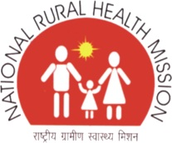


INTENSIFIED DIARRHOEA CONTROL FORTNIGHT

IDCF toolkit
Contains:

TRAINING GUIDE

Child Health Division
Ministry of Health & Family Welfare

July 2015

SESSION PLAN FOR OF ONE DAY TRAINING ON IDCF

Time | KEY ASPECTS TO BE COVERED
9.00A.M.-10.30A.M. | Role CLARITY OF ANM/ASHA/AWW ON IDCF
10.30 A.M. | TEA BREAK
11.00A.M.-1.00 P.M. | TECHNICAL SESSION ON DIARRHOEA MANGEMENT.  The session must lead to:  - ANM/ASHA aware and competent on detection of dehydration  - ANM/ASHA are able to choose Plan A/B/C for management of dehydration in children  - ANM/ASHA aware of dosage of ORS/zinc for childhood diarrhea management  - ANM/ASH are aware of key information for prevention of Diarrhoea  - ANM/ASHA are aware of nutritional messages during diarrhoea
1.00 P.M. – 2.00 P.M. | Lunch
2.00 p.m. – 4.00 P.M. | Technical session on iycf:  The session must lead to:  - ANM/ASHA aware of key IYCF practices  - ANM/SHA are able to provide counselling for correct breastfeeding attachment, positioning, frequency and common breast conditions  - ANM/ASHA are able to provide correct diet plan for complementary feeding – consistency, frequency, diversity of diet  - ANM/ASHA able to counsel mothers for preparing nutritious diet with locally available food

Diarrhoea is a very common problem in the children under five. Diarrhoea can be serious – and even lead to death.

TRAINING OBJECTIVES
After training, ASHA, ANM and Medical Officers will be able to:

✔ Define the types of diarrhoea and levels of dehydration
✔ Recognize clinical signs of dehydration
✔ Assess diarrhoea in sick children
✔ Assess dehydration in young infants and sick children
✔ Classify diarrhoea and severity of dehydration using standard charts
✔ Treat using Plans A, B, and C for dehydration
✔ Counsel the caregiver about home treatment for diarrhoea

KNOWLEDGE TEST

Circle the best answer for each question.

How can diarrhoea kill children? | - Children lose valuable fluids, salts, and sugars, which can cause shock to vital organs  - Children lose valuable nutrients because they cannot eat  - Diarrhoea causes liver failure
What are critical treatments for children with diarrhoea and dehydration? | - Oral antibiotics  - Oral rehydration therapy and zinc  - Paracetamol for discomfort
What is persistent diarrhoea? | - When a child frequently has diarrhoea over a period of 1 month, and is ill as a result  - When a child has several episodes of diarrhoea a day  - When a child has an episode of diarrhoea lasting 14 days or more, which is particularly dangerous for dehydration and malnutrition
Critical messages for caregivers about diarrhoea and dehydration include: | - The child must receive increased fluids, ORS, zinc, and regular feeding  - The child requires ORS, but should receive less food in order to reduce the diarrhoea  - The child should immediately receive antibiotics to stop the diarrhoea
Rani arrives at your health facility and is very lethargic. Her eyes are very sunken. She has diarrhoea. You observe a significant loss of skin elasticity. How will you manage Rani? | - Rani requires ORS immediately, as she is dehydrated.  - These are common signs of diarrhoea, as the child’s body is exhausted.  - Rani is severely dehydrated. She requires urgent rehydration therapy by IV or nasogastric tube.

INTRODUCTION TO DIARRHOEA AND ITS MANAGEMENT PROTOCOLS

WHAT IS DIARRHOEA?

Diarrhoea occurs when stools contain more water than normal, and are loose or watery. In many regions diarrhoea is defined as three or more loose or watery stools in a 24-hour period. Children between the ages of 6 months and 2 years often have diarrhoea. It is more common in settings of poor sanitation and hygiene, including a lack of safe drinking water.
Most diarrhoea that causes dehydration is loose or watery.

WHAT ARE THE TYPES OF DIARRHOEA IN CHILDREN?

Type of Diarrhoea | Definition
ACUTE DIARRHOEA | Is an episode of diarrhoea that lasts less than 14 days. Acute watery diarrhoea causes dehydration and contributes to malnutrition. The death of a child with acute diarrhoea is usually due to dehydration
PERSISTENT DIARRHOEA | If an episode of diarrhoea that lasts for 14 days or more. [Up to 20% of episodes of diarrhoea become persistent, and this often causes nutritional problems and contributes to death in children]
DYSENTERY | Diarrhoea with blood in the stool, with or without mucus. The most common cause of dysentery is Shigella bacteria. Amoebic dysentery is not common in young children. A child may have both watery diarrhoea and dysentery.

*for the purpose of health workers any diarrhoea that lasts for more the 14 days should be considered severe persistent diarrhoea and referred to health facility

WHAT ARE THE TYPES OF DIARRHOEA IN YOUNG INFANTS?
A young infant has diarrhoea if the stools have changed from the usual pattern, and are many and watery. This means more water than faecal matter. The normally frequent or semi-solid stools of a breastfed baby are not diarrhoea.

- WHAT IS DEHYDRATION?

Diarrhoea can be a serious problem – and even lead to death – if child becomes dehydrated. Dehydration is when the child loses too much water and salt from the body. This causes a disturbance of electrolytes, which can affect vital organs.

A child who is dehydrated must be treated to help restore the balance of water and salt. Many cases of diarrhoea can be treated with Oral Rehydration Salts (ORS), a mixture of glucose and several salts. ORS and extra fluids can be used as home treatment to prevent dehydration. Low osmolarity ORS should be used to treat dehydration.

HOW TO ASSESS DEHYDRATION?
There are several signs that help to decide the severity of dehydration. When a child becomes dehydrated, he is at first restless or irritable. As the body loses fluids, the eyes may look sunken, and skin loses elasticity. If dehydration continues, the child becomes lethargic or unconscious.

LOOK: AT THE CHILD’S GENERAL CONDITION
When you checked for general danger signs, you checked to see if the child was lethargic or unconscious. If the child is lethargic or unconscious, he has a general danger sign. Remember to use this general danger sign when you classify the child’s diarrhoea.

A child is classified as restless and irritable if s/he is restless and irritable all the time or every time s/he is touched and handled. If an infant or child is calm when breastfeeding but again restless and irritable when he stops breastfeeding, s/he has the sign restless and irritable. Many children are upset just because they are in the health facility. Usually these children can be consoled and calmed, and do not have this sign.
FOR THE YOUNG INFANT: watch the infant’s movement. Does he move on his own? Does the infant only move when stimulated, but then stops? Is the infant restless and irritable?
LOOK FOR SUNKEN EYES

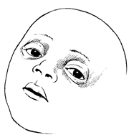
The eyes of a child who is dehydrated may look sunken. Decide if you think the eyes are sunken. Then ask the mother if she thinks her child’s eyes look unusual. Her opinion can help you confirm. NOTE: In a severely malnourished child who is wasted, the eyes may always look sunken, even if the child is not dehydrated. Still use the sign to classify dehydration.
LOOK: TO SEE HOW THE CHILD DRINKS
Ask the mother to offer the child some water in a cup or spoon. Watch the child drink.
- A child is not able to drink if he is not able to suck or swallow when offered a drink. A child may not be able to drink because he is lethargic or unconscious.
- A child is drinking poorly if the child is weak and cannot drink without help. He may be able to swallow only if fluid is put in his mouth.
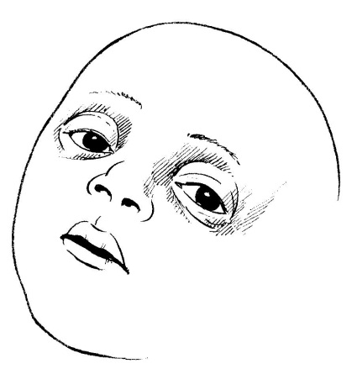
- A child has the sign drinking eagerly and acts thirsty if it is clear that the child wants to drink. Look to see if the child reaches out for the cup or spoon when you offer him water. When the water is taken away, see if the child is unhappy because he wants to drink more. If the child takes a drink only with encouragement and does not want to drink more, he does not have the sign drinking eagerly, thirsty.
FEEL: BY PINCHING THE SKIN OF THE ABDOMEN

This skin pinch tests is an important tool for testing dehydration. When a child is dehydrated, the skin loses elasticity. To assess dehydration using the skin pinch:

- ASK the mother to place the child on the examining table so that the child is flat on his back with his arms at his sides (not over his head) and his legs straight. Or, ask the mother to hold the child so he is lying flat on her lap.
- USE YOUR THUMB AND FIRST FINGER to locate the area on the child’s abdomen halfway between the umbilicus and the side of the abdomen. Do not use your fingertips because this will cause pain. The fold of the skin should be in a line up and down the child’s body.
- PICK UP all the layers of skin and the tissue underneath them.
- HOLD the pinch for one second. Then release it.
- LOOK to see if the skin pinch goes back very slowly (more than 2 seconds), slowly, (less than 2 seconds, but not immediately), or immediately. If the skin stays up for even a brief time after you release it, decide that the skin pinch goes back slowly. The photographs below show you how to do the skin pinch test and what the skin looks like when the pinch does not go back immediately.
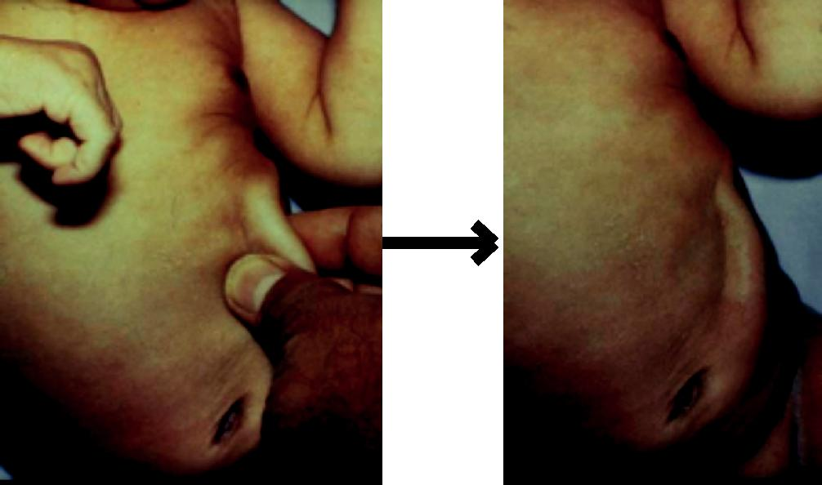

Skin pinch Skin pinch going back very slowly
NOTE: The skin pinch test is not always an accurate sign. In a child with severe malnutrition, the skin may go back slowly even if the child is not dehydrated. In a child is overweight or has edema, the skin may go back immediately even if the child is dehydrated. However you should still use it to classify the child’s dehydration.

- HOW TO CLASSIFY DEHYDRATION?

There are three possible classifications for the type of diarrhoea. These are:

- SEVERE DEHYDRATION (RED)

Classify as SEVERE DEHYDRATION if the child has two or more of the following signs: lethargic or unconscious, not able to drink or drinking poorly, sunken eyes, or very slow skin pinch.
ACTION
Any child with dehydration needs extra fluids. A child classified with SEVERE DEHYDRATION needs fluids quickly. Treat with IV (intravenous) fluids. “Plan C: Treat Severe Dehydration Quickly” on the TREAT chart is annexed and describes how to give fluids to severely dehydrated children.
- SOME DEHYDRATION (YELLOW)

If the child does not have signs of SEVERE DEHYDRATION, look at the next row. Does the child have signs of SOME DEHYDRATION? If the child has two or more of the following signs – restless, irritable; drinks eagerly, thirsty; sunken eyes; skin pinch goes back slowly – classify as SOME DEHYDRATION.
ACTION

If a child has one sign in the red (top) row and one sign in the yellow (middle) row, classify the child in the yellow row (SOME DEHYDRATION). A child who has SOME DEHYDRATION needs fluid, foods and zinc supplements. Treat the child with ORS solution and Zn supplementation. In addition to fluid, the child with SOME DEHYDRATION needs food. Breastfed children should continue breastfeeding. Other children should receive their usual milk or some nutritious food after 4 hours of treatment with ORS. The treatment is described in the box “Plan B: Treat Some Dehydration with ORS”. One will learn more about ORS and zinc supplements in the next section.
- NO DEHYDRATION (GREEN)

A child who does not have two or more signs in the red or yellow row is classified as having NO DEHYDRATION. This child needs extra fluid and foods to prevent dehydration.

The four rules of home treatment are:

- Give extra fluid

- Give zinc supplements

- Continue feeding

- Return immediately if the child develops danger signs, drinks poorly, or has blood in stool
ACTION

The treatment box called “Plan A: Treat Diarrhoea At Home” describes what fluids to teach the mother to give and how much she should give. A child with NO DEHYDRATION also needs food and zinc supplements. You will learn more about Plan A and zinc in the next section.
After classifying dehydration, classify the child for persistent diarrhoea if the child has had diarrhoea for 14 days or more. Then classify for dysentery.

- HOW TO CLASSIFY AND MANAGE CHILDREN WITH DIARRHOEA?

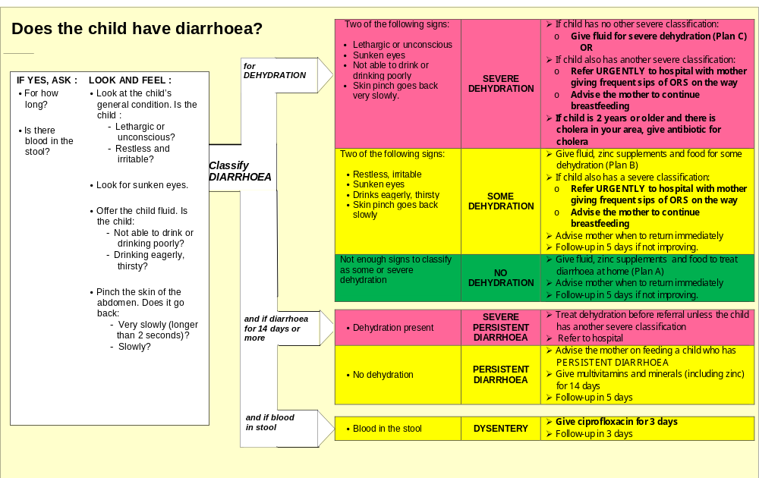
CHART 1: DIARRHOEA ASSESS, CLASSIFY AND MANAGEMENT PROTOCOL FOR CHILDREN

CHART 2: DIARRHOEA ASSESS, CLASSIFY AND MANAGEMENT PROTOCOL FOR YOUNG INFANT(<2 months age)
(< 2 months age)

HOW TO TREAT THE CHILD WITH DIARRHOEA

WHAT TREATMENTS ARE IDENTIFIED FOR DIARRHOEA AND DEHYDRATION?

The color-coded classifications also indicate where the treatment can be delivered – by urgent referral, at the health facility, or at home.

Identified treatments are listed below. These are all new treatments, so you will learn about all of them in this section:

✔Plans A, B, and C for giving fluids and food

✔Giving ORS for dehydration

✔Zinc supplementation

✔Ciprofloxacin for dysentery

WHAT ARE THE KEY STEPS FOR MANAGEMENT OF DIARRHOEA IN CHILDREN?
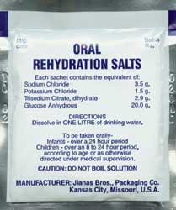
4 key interventions: Manage a case of childhood diarrhoea
- Rehydrate the child with ORS solution (in case of no-dehydration follow Plan A at home, in case of some dehydration follow Plan B at health facility level) or with IV fluids (in case of severe dehydration follow Plan C by use of IV fluids at health facility). Stop rehydration once diarrhoea stops.
- Administer Zinc dispersible tablets for 14 days, even after diarrhoea stops.
- Continued age appropriate feeding.
- Rational use of antibiotics

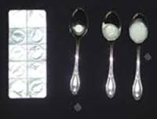

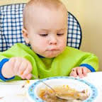

=



PLAN A FOR TREATMENT OF DIARRHOEA AT HOME

GIVE EXTRA FLUID FOR DIARRHOEA AND CONTINUE FEEDING
(See feeding advice and counsel the mother)
Plan A: Treat for Diarrhoea at Home

Counsel the mother on the 4 Rules of Home Treatment:
1. Give Extra Fluid 2. Give Zinc Supplements (age 2 months up to 5 years) 3. Continue Feeding 4. When to Return

- GIVE EXTRA FLUID (as much as the child will take)

➢ TELL THE MOTHER:
- Breastfeed frequently and for longer at each feed
- If the child is exclusively breastfed, give ORS or clean water in addition to breast milk
- If the child is not exclusively breastfed, give one or more of the following:
food-based fluids (such as soup, rice water, and yoghurt drinks), or ORS

It is especially important to give ORS at home when:
- the child has been treated with Plan B or Plan C during this visit
- the child cannot return to a clinic if the diarrhoea gets worse

➢ TEACH THE MOTHER HOW TO MIX AND GIVE ORS. GIVE THE MOTHER 2
PACKETS OF ORS TO USE AT HOME.

➢ SHOW THE MOTHER HOW MUCH FLUID TO GIVE IN ADDITION TO THE USUAL FLUID INTAKE:
Up to 2 years: 50 to 100 ml after each loose stool
2 years or more: 100 to 200 ml after each loose stool

Tell the mother to:
- Give frequent small sips from a cup.
- If the child vomits, wait 10 minutes then continue - but more slowly
- Continue giving extra fluid until the diarrhoea stops
- GIVE ZINC (age 2 months up to 5 years)

- TELL THE MOTHER HOW MUCH ZINC TO GIVE (20 mg tab) :
2 months up to 6 months ——- 1/2 tablet daily for 14 days
6 months or more ——- 1 tablet daily for 14 days

- SHOW THE MOTHER HOW TO GIVE ZINC SUPPLEMENTS
- Infants—dissolve tablet in a small amount of expressed breast milk, ORS or clean water in a cup
- Older children - tablets can be chewed or dissolved in a small amount of clean water in a cup
- CONTINUE FEEDING (exclusive breastfeeding if age less than 6 months)
- WHEN TO RETURN

Revise 4 RULES OF HOME TREATMENT

The four rules of home treatment are very important to remember:

- Give extra fluid – as much as the child will take

- Give zinc

- Continue feeding

- When to return (for a follow-up visit, or immediately if danger signs develop)
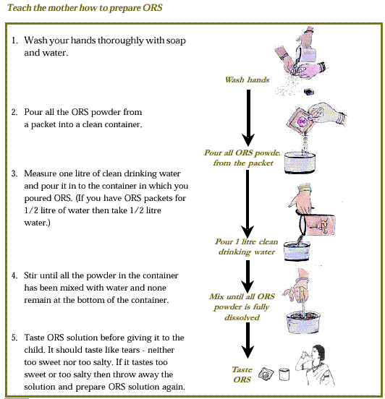
TEACH THE CAREGIVER TO PREPARE ORS?

Ask the mother to give one teaspoon of the solution to the child. This should be repeated every 1-2 minutes (An older child who can drink it in sips should be given one sip every 1-2 minutes).

If the child vomits the ORS tell the mother to wait for 10 minutes and resume giving the ORS but this time more slowly than before. Breast fed babies should be continued to be given breast milk in between ORS. Any ORS which is left over after 24 hours should be thrown away.

Use the table below to determine the amount of ORS that should be given to the child in 4 hours.

After about 4 hours of giving ORS, reassess the child for dehydration. If the child is no longer dehydrated, tell the mother to give home available fluids the same way as she gave ORS. Details of what home available fluids to give are given in the next section. Begin feeding the child even if dehydration persists, continue ORS. If the child is still dehydrated, refer. On the way mother should continue to give ORS to the child.

 | AGE
ORS | Up to 4 months | 4 months up to  12 months | 12 months up to 2 years | 2 years up to  5 years
 | 2 | 3 | 5 | 7
Cups | 

CONTINUE USE OF ORS AT HOME
How the care-giver get ORS to use in the home? | How to teach the caregiver to give ORS?
Give the caregiver 2 packets of ORS to use at home. Show her how much fluid should be given in addition to the usual fluid intake:  - Up to 2 years: 50–100 ml after each loose stool  - 2 years or older: 100–200 ml after each loose stool | Finally, give the caregiver instructions for giving ORS:  - Give frequent small sips from a cup  - If child vomits, wait 10 minutes. Then continue, but more slowly.  - Continue giving extra fluid until the diarrhoea stops

PLAN B [SOME DEHYDRATION]
CHART 3: PLAN B FOR TREATMENT OF SOME DEHYDRATION

Treat at health facility/ ORS centers
A child or young infant with some dehydration needs fluid, zinc supplementation, and food. Give zinc just as for Plan A.

GIVE EXTRA FLUID FOR DIARRHOEA AND CONTINUE FEEDING
(See feeding advice and counsel the mother)
Plan B: Treat for Some Dehydration with ORS

In the clinic, give recommended amount of ORS over 4-hour period

➢ DETERMINE AMOUNT OF ORS TO GIVE DURING FIRST 4 HOURS
* Use the child’s age only when you do not know the weight. The approximate amount of ORS required (in
ml) can also be calculated by multiplying the child’s weight in kg times 75.
Age* | Up to 4 months | 4 months to 12 years | 12 months to 2 years | 2 years to 5 years
Weight | < 6 kg | 6- < 10 kg | 10 - < 12 kg | 12 - < 20 kg
Amount of fluid (ml) over 4 hours | 200-450 | 450 -800 | 800-960 | 960-1600

- If the child wants more ORS than shown, give more
- For infants below 6 months who are not breastfed, also give 100-200ml clean
water during this period

➢ SHOW THE MOTHER HOW TO GIVE ORS SOLUTION:
• Give frequent small sips from a cup
• If the child vomits, wait 10 minutes then continue - but more slowly
• Continue breastfeeding whenever the child wants

➢ AFTER 4 HOURS:
• Reassess the child and classify the child for dehydration
• Select the appropriate plan to continue treatment
• Begin feeding the child in clinic

➢ IF THE MOTHER MUST LEAVE BEFORE COMPLETING TREATMENT:
• Show her how to prepare ORS solution at home
• Show her how much ORS to give to finish 4-hour treatment at home
• Give her instructions how to prepare salt and sugar solution for use at home
• Explain the 4 Rules of Home Treatment:

- GIVE EXTRA FLUID
- GIVE ZINC (age 2 months up to 5 years)
- CONTINUE FEEDING (exclusive breastfeeding if age less than 6 months)
- WHEN TO RETURN

Teach care giver the signs when to return immediately to a health worker.
Tell the mother of any sick child that the signs to return are: | If the child has diarrhoea, also tell the mother to return if the child has:
Not able to drink or breastfeed  Becomes sicker  Develops a fever | Blood in stool  Drinking poorly – also includes not able to drink or breastfeed

---------------------------------------------------------------------------------

PLAN C [SEVERE DEHYDRATION]
Severely dehydrated children and young infants need to have water and salts quickly replaced. Plan C requires rapid hydration using IV fluids or a nasogastric (NG) tube. It is important to note that rehydration therapy using IV fluids or using a nasogastric (NG) tube is recommended only for children who have SEVERE DEHYDRATION.

WHERE IS PLAN C GIVEN?

Health facility, where is the safest place to give plan c?
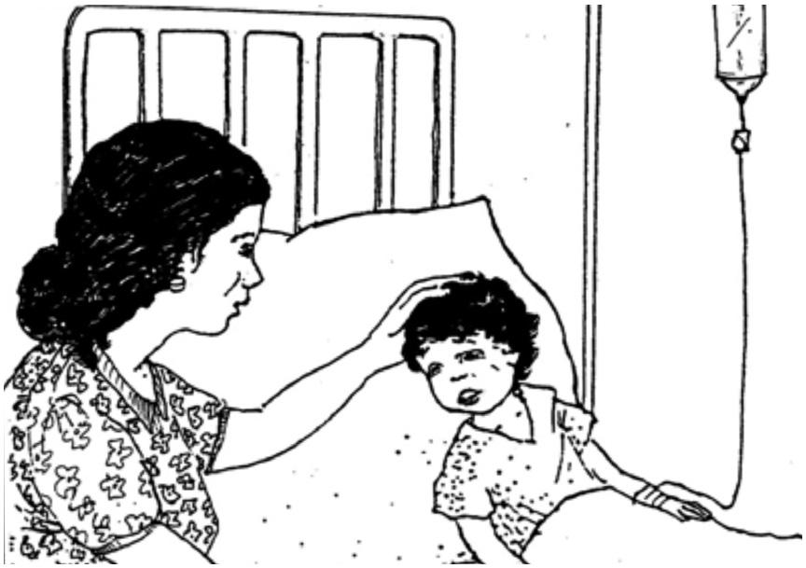
This is important for you to determine based on available equipment and your training. If you cannot give IV or NG fluid and the child cannot drink, refer the child urgently to the nearest hospital that can give IV or NG treatment.

If IV (intravenous) treatment is available within a 30-minute drive, refer urgently to hospital for treatment with IV fluids. On the way to hospital, have the mother offer frequent sips of ORS to her sick child.

Plan C should only be provided in the health facility or the ORS/ORT centers and administered by medical officer to manage severely dehydrated children and young infants

what is the FEEDING ADVICE to be given DURING DIARRHOEA?

Upto 6 months of age  Breastfeed exclusively  Breastfeed as often as the child wants, day and night, at least 8 times in 24 hours  Do not give other foods or fluids  Continue breastfeeding even if the child is ill | 6 months upto 12 months of age  Breastfeed as often as the child wants  Give each time at least 1 katori of :  - Undiluted sweetened milk with mashed roti/rice/biscuit/bread  - Thick dal with added oil with mashed roti/rice/bread or khichri with added oil; add vegetables to the meal  - Sevian or dalia or halwa or kheer prepared in milk or other milk based preparations  - Mashed boiled or fried potatoes or potato subzi without spices  - Banana or biscuits or cheeku or mango or papaya as snacks  Feed 3 times a day if breastfed or 5 times per day if not breastfed | 12 months upto 2 years of age  Breastfeed as often as the child wants.  Give each time at least 1½ katori of:  - Thick dal with added oil with mashed roti/rice/bread or khichri with added oil; add vegetables to the meal  - Undiluted sweetened milk with mashed roti/rice/biscuit/bread  - Sevian or dalia or halwa or kheer prepared in milk or other milk based preparations  - Mashed or fried potatoes or potato subzi without spices  - Banana or biscuits or cheeku or mango or papaya as snacks  Feed 5 times per day | >2 years  Feed family foods or snacks.  Feed 5times a day
Note
- Continue breastfeeding and feeding all foods in the recommended amounts even if the child is ill
- Make the child (6-11 months) sit in your lap and feed the child yourself; and help the older child eat and finish all food
- Wash your and child’s hands with soap before a meal

when to refer child with diarrhoea to higher health facility?

Refer children urgently to the Hospital if they have the following:

Age <2 months
- Child passing blood in stools
- Severe dehydration
- Not able to drink or breastfeed
- Vomits everything
- Convulsions
- Lethargic or unconscious
- Cough or difficult breathing and fast breathing or ‘pneumonia’ or ‘paslichalna’
- Other associated illness
- Severe malnutrition
- If diarrhea more than 14 days

WHAT ARE THE COMMON LOCAL MISCONCEPTIONS WITH PEOPLE THAT NEEDS TO BE REJECTED BY HEALTH WORKER?
- ORS and glucose are the same
- ORS should not to be given in winter even when the child has diarrhea
- ORS should be given in summer even when the child does not have diarrhea. In such cases, if you feel that due to heat child needs extra fluid, give shikanji, lassi and other fluids at home.
- Some foods should be reduced in diarrhea
- Feeding during diarrhea will worsen the case.
- Breastfeeding should be reduced in diarrhea
- Diarrhea due to extremes of weather, evil spirits (uprihawa) or indigestion does not need any treatment

REVIEW QUESTIONS

AFTER THE TRAINING: CHECK WHAT DO THE PROVIDERS NOW KNOW ABOUT MANAGING DIARRHOEA AND DEHYDRATION?

Before you began studying this section, practice the knowledge on with several questions. Now that you have finished the training, answer the same questions. This will help demonstrate what you have learned.

Circle the best answer for each question.

- How can diarrhoea kill children?

  - Children lose valuable fluids, salts, and sugars, which can cause shock to vital organs
  - Children lose valuable nutrients because they cannot eat

  - Diarrhoea causes liver failure

- What are critical treatments for children with diarrhoea and dehydration?

  - Oral antibiotics

  - Oral rehydration therapy and zinc

  - Paracetamol for discomfort

- What is persistent diarrhoea?

  - When a child frequently has diarrhoea over a period of 1 month, and is ill as a result
  - When a child has several episodes of diarrhoea a day

  - When a child has an episode of diarrhoea lasting 14 days or more, which is particularly dangerous for dehydration and malnutrition

- Critical messages for caregivers about diarrhoea and dehydration include:

  - The child must receive increased fluids, ORS, zinc, and regular feeding

  - The child requires ORS, but should receive less food in order to reduce the diarrhoea
  - The child should immediately receive antibiotics to stop the diarrhoea

- Rani arrives at your health facility and is very lethargic. Her eyes are very sunken. She has diarrhoea. You observe a significant loss of skin elasticity. How will you manage Rani?

  - Rani requires ORS immediately, as she is dehydrated.

  - These are common signs of diarrhoea, as the child’s body is exhausted.

  - Rani is severely dehydrated. She requires urgent rehydration therapy by IV or nasogastric tube.

ANSWER KEY
QUESTION | ANSWER | If one misses the question? Return to this section to read and practice:
1 | A | INTRODUCTION
2 | B | CLASSIFY, TREAT
3 | C | CLASSIFY
4 | A | TREAT, COUNSEL THE CAREGIVER
5 | C | CLASSIFY, TREAT

SECTION B

INFANT AND YOUNF CHILD FEEDING

TRAINING OBJECTIVES
After training, ASHA, ANM and Medical Officers will be able to:

- Understand the importance of breast feeding.
- Assess breastfeeding and complementary feeding
- Measure children, plot measurements on growth charts, and
- Interpret growth indicators and counsel and support mothers to carry out recommended feeding practices for their infants and young children.

INTRODUCTION:
The optimal Infant and Young Child Feeding Practices comprise of following:

a. Early initiation of breastfeeding; immediately after birth, preferably within one hour.

b. Exclusive breastfeeding for the first six months of life i. e 180 days (no other foods or fluids, not even water; but allows infant to receive ORS, drops, syrups of vitamins, minerals and medicines when required).

c. Timely introduction of complementary foods (solid, semisolid or soft foods) after the age of six months i. e 180 days.

d. Continued breastfeeding for 2 years or beyond.

e. Age appropriate complementary feeding for children 6-23 months, while continuing breastfeeding. Children should receive food from 4 or more food groups [(1) Grains, roots and tubers, legumes and nuts; (2) dairy products ; (3) flesh foods (meat fish, poultry); (4) eggs, (5) vitamin A rich fruits and vegetables; (6) other fruits and vegetables] and fed for a minimum number of times (2 times for breasted infants 6-8 months; 3 times for breastfed children 9-23 months; 4 times for non-breastfed children 6-23 months).

f. Active feeding for Children during and after illness.

Part I:
1. Why is it recommended that baby should be given only mother’s milk and not any other milk?
Mother’s milk is a natural complete food for the baby. Breastfeeding offers many advantages to mother and infant. These are listed below. Baby and mother will not get these benefits if cow, buffalo or formula milk is used for feeding.
Advantages offered by Breastmilk and Breastfeeding
For the baby:
1. All the nutrients are in proper proportion for optimal growth and development
2. Easily digestible
3. Germ free as it is transferred directly from the mother to the baby
4. Provides immunity and protection against infections e.g. pneumonia, diarrhoea
5. At right temperature, Convenient and requires no preparation
6. Makes child more intelligent
7. Protection against asthma and allergies
8. Protection against obesity, hypertension, heart disease and diabetes in later life
9. Decreased risk of some cancers
10. Stronger Mother - Infant bonding
11. It is free of cost

For the mother:
1. Looses fat through breastmilk. Helps her to get back in shape
2. Decreased risk of breast, ovarian and uterine cancers
3. Helps to delay next pregnancy; but the mother should not depend on this as the sole method of contraception. (To consult doctor six weeks post-delivery)
4. Early expulsion of placenta
5. Uterus contracts faster to pre-pregnancy state
6. Decreased post-delivery bleeding
7. Family saves on medical expenses as child falls less sick.

8. Breastfeeding helps a mother and baby to form a close, loving relationship, which makes mothers feel deeply satisfied emotionally. Close contact from immediately after delivery helps this relationship to develop. This process is called bonding.

Note: Breastfeeding is advantageous not only for the mother and baby but also for the overall development of the society and the nation.

2. How should she and family prepare for breastfeeding? Should she take some special care of breasts and nipples?
- All family members should provide encouragement, adequate time and supportive environment for breastfeeding.
- Family should share the workload after baby is born
- Breasts and nipples undergo natural changes as the pregnancy advances.
- The nipples which initially appear smaller become optimally fit for feeding by the time of delivery.
- The mother should not worry about the size of the breasts because milk production does not depend on it. The breast size varies due to differences in amount of fat. Amount of milk producing glandular tissue is almost same in all the mothers.
- Proper clothes that facilitate breastfeeding need to be kept ready. Sari-Blouse, shirt or gown (full front opening) is best suited for this purpose.

3. When should breastfeeding begin after delivery and how? What area the benefits of early Initiation?
- Soon after delivery of the baby, breastfeeding should begin.
- Mother should be promoted to hold the baby close in 5 min ( skin to skin contact)
- After caesarean delivery, the mother should start breastfeeding as soon as she re-gains consciousness (maximum four hours).

Following are the benefits of early initiation.

1. Baby is very alert and eager to breastfeed in the first hour after delivery.
2. The child remains warm being in close touch with the mother
3. Child receives Colostrum so risk of infections is reduced
4. 5. Post-delivery bleeding (Post-partum hemorrhage) decreases
6. A strong emotional bond begins to develop between the mother and the baby.
Note: The first skin-to-skin contact should continue till completion of the first breastfeed.

4. How to initiate breastfeeding?
What should mother do if enough milk is not produced initially What is colostrum and what are its benefits?
- The relatives and health care providers should motivate the mother to give frequent skin to skin contact and allow the child to suck often
- Sucking stimulates milk production
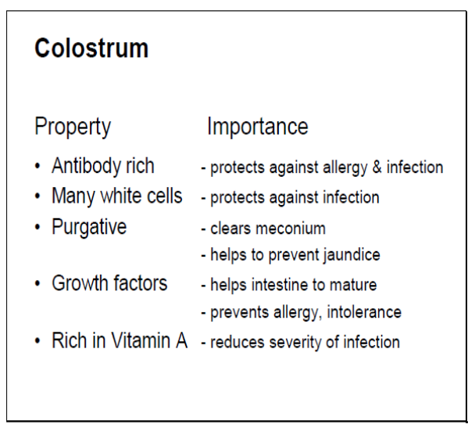
- If enough milk is not produced initially make the child suck
- Do not give any milk or fluids (water, glucose, honey etc.)
- If the mother still doesn’t produce milk then consult a doctor
- Mother produces a yellow fluid known as colostrum for two- three days after delivery. This is beneficial and should not be thrown away.

Following are the benefits of colostrum:

1. Rich in antibodies (immunity) and protects the baby against infections. Hence it is the first vaccine for the baby.
2. Helps the baby to pass her first stool (meconium). This helps to reduce the severity of physiological (normal) jaundice.
4. Rich in vitamins A and K

5) Is it appropriate to follow the tradition of giving honey, sugar water, etc. to the baby before the first breastfeed (Pre-Lacteal feeds)?
Traditionally, sometimes the baby is fed some fluid before the first breastfeed or during first three to five days of life (before the mother starts producing mature milk). This is known as ‘Pre-lacteal feed’. This custom is inappropriate, because it increases the risk of infection. This pre-lacteal feed may decrease the baby’s eagerness to suckle at the breast. Thus the first and the subsequent breastfeeds may get delayed. This may lead to breastfeeding failure.

6) How frequently and how long should the child be breastfed?
- It is necessary to feed the baby more frequently during the first seven days (at least 8-10 times in 24 hours).
- Only after child starts urinating frequently (more than 6 times in 24 hrs.) and starts gaining weight that the baby can be fed on demand i.e. whenever the baby wants and as long as she wants. .
- Children donot have a definite timetable or pattern, so mothers should understand and adjust to suit baby’s needs.
Mother should feed on one side as long as possible because the milk which comes initially is rich in water & sugar (foremilk), while the milk which comes in the later part of the breastfeed is rich in fats (hind milk).

8) How should the mother hold the child while breastfeeding?

How baby suckles from the breast
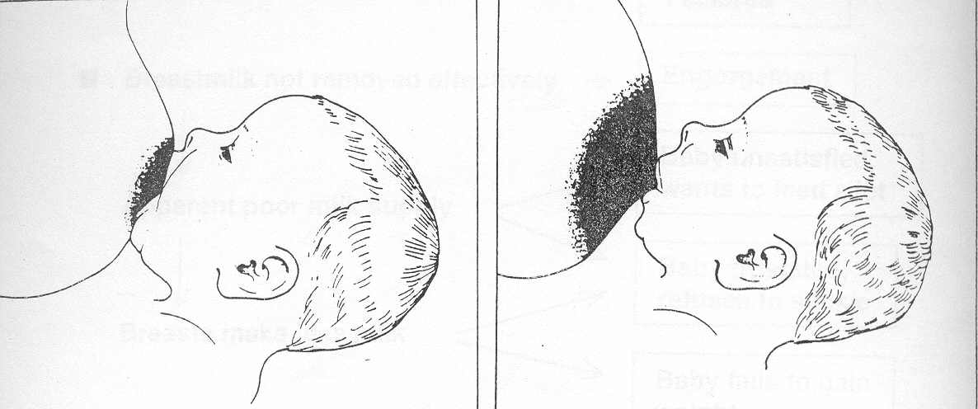
Correct Attachment Incorrect Attachment

Baby’s Attachment (Refer to diagram on page 12)
1. Max possible areola in baby’s mouth (Lower portion more).
2. Mouth wide open.
3. Lower lip turned outward.
4. Chin touches the breast.

Baby’s Position
1. Turned towards the mother.
2. Good skin to skin contact.
3. Head & body in one line.
4. Neck, back & buttocks well supported.

Mother’s Position
1. Sitting comfortably with good back support
2. Holding breast in big ‘C’ grip of hand
3. Touches nipple to upper lip by bringing nipple in front of nose & gives mouthful of breast as soon as the baby opens the mouth widely
4. Interacting with baby while feeding

Figure: How does the mother hold her baby?
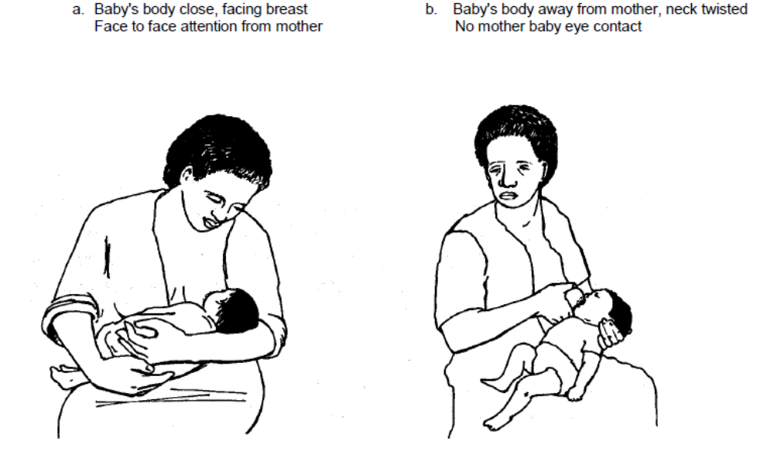
Correct incorrect
Figure : How does the mother hold her breast?
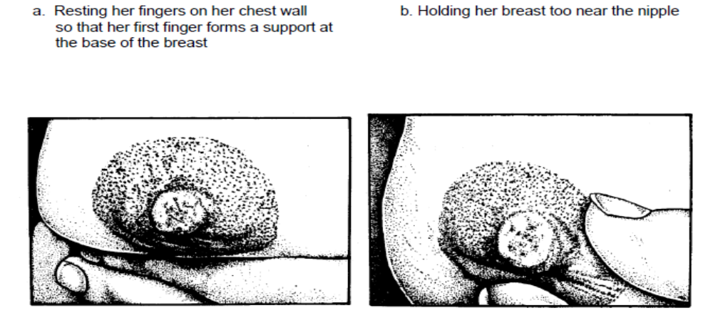
Correct incorrect
Note: If child is more than one month old and it is certain that the baby is getting enough milk, it may not be wise to instruct the mother regarding attachment and positioning.

9. What is the cause of cracked / sore nipples? What is the remedy?
If the baby’s attachment to the breast is not as described as shown above, then it causes cracked/sore nipples. The prevention / remedy is learning correct attachment after this the mother should apply hind-milk to the cracked/sore nipple and leave it open to the air for some time. Frequent washing of nipple and areola with soap and water can cause drying and cracks by removing the natural oily substance which normally covers this area. Routine once a day cleaning of the breasts during bath is sufficient. Nipple may get cracked at the base if the child is taken away abruptly from the breast while feeding. Hence if the baby has to be removed from the breast, the mother should insert her little finger in baby’s mouth and detach the baby slowly.

Note: To avoid cracked/sore nipples mother should learn the proper technique of attachment right from the first breastfeed. Ensuring that mother does not feel pain while feeding confirms good attachment.

10. What should a mother do if breasts get hard and lumpy (engorgement)? What causes this?
The mother starts producing milk (i.e. mature milk) from three to five days after the delivery. Excessive production of milk or incomplete emptying of breast (Infrequent suckling or poor attachment) will cause heaviness, hardening and pain (engorgement). Engorgement restricted to a part of the breast will give a lumpy feel. Engorgement of the breast tissue which is normally present in the armpit will produce a lump there. Engorgement may sometimes be caused if the child has overslept and not fed.
Breasts become full and little heavy just prior to a breastfeed (Full Breasts). Breasts will start getting engorged if not emptied for some more time (Engorgement). Engorgement can be prevented by timely expression of milk. Hence it is essential that every mother knows this technique of expression (The instructor should use the extensor aspect of a flexed elbow to explain the technique). Unattended engorgement can lead to increasing pain, redness over a part of the breast and fever (Mastitis). If neglected, this may progress to pus formation (Breast Abscess).

11. How long should the baby be breastfed? When should water, gripe water, balkadu etc be given to the baby?
The baby should be given only mother’s milk (Exclusive Breastfeeding) for the first six months of life. Even water is not necessary during this period. Breastmilk contains enough water to take care of baby’s needs even in summer.
Baby should NOT be fed with traditional items like balguti, gripe water, balkadu multivitamin/mineral preparations etc. Feeding these items may cause frequent infections. Semi solid food (complementary foods ) should be started only at the end of six months. However breastfeeding should continue along with complementary foods at least till second birthday and beyond .

12. How to know that the baby is getting enough breastmilk?
There are two gold standards to know if the baby is getting enough breastmilk; of this, one can be easily observed at home. If an exclusively breastfed baby is urinating at least 6-7 times in a day, i.e. in any 24 hour period, it implies that she is getting enough. One can draw the same conclusion if the child gains at least half a kilo, i.e. 500 grams every month. These two tests cannot be used for about a week or two after birth when breastfeeding is getting established. During the first 3-5 days the baby passes urine infrequently and a full term newborn loses 7-8 % weight. Increasing urine output and weight after 3-5 days of birth indicate that the mature milk has come in and baby is getting it in good quantities. Baby regaining birth weight by 15th day of life has similar implications. Baby doubles her birth weight in about 5 months and triples in one year.

Mother may feel that her milk is inadequate due to following reasons:
1. If a child cries excessively. A baby may cry for many reasons other than hunger. A baby can express any discomfort only by crying.
2. Milk comes in between 3-5 days after delivery. This can sometimes cause heaviness and mild engorgement of the breasts. However after a few days this heaviness passes off and breasts again become soft. Hence mother may feel that she is not getting enough milk.
3. The child often sucks at fingers (mouthing); but this is quite common and does not necessarily imply that the baby is hungry.
4. 5. Babies grow faster during some periods (Growth Spurts). Babies feed frequently for longer periods during growth spurts.

Note: Frequent suckling (with correct attachment) more milk.

13. Should breastfeeding be stopped during mother’s illnesses?
It is not necessary for a mother to stop breastfeeding even if she is suffering from fever/cold/cough/vomiting/diarrhoea/and many other common illnesses and infections. Since the mother and the child live in the same environment and are in close contact, the child is usually infected by the time mother shows the symptoms. The child may have a shorter illness because it gets the antibodies (immunity) produced in the mother’s body through breastmilk.

14. Is it correct to enforce dietary restrictions on mother with the fear that some food substances can affect baby’s health?
Breastmilk is produced from blood. Composition of blood remains unchanged irrespective of what mother eats and so does composition of breastmilk. However it is necessary that the mother takes a balanced diet and also eats some extra food to support lactation. Routine tradition of giving ghee enriched sweet preparations to a breastfeeding mother would stand to reason only if she is undernourished, or else this would only contribute to making mother more obese. The mother should avoid eating outside food due to the risk of contracting an infection.

15. Is it all right to use a bottle for giving water or milk to a child?
It is always unsafe to use the bottle. The risk of vomiting and loose motions (acute gastroenteritis) and other infectious diseases is much higher in bottle fed babies. Since it is easier to feed from a bottle, the child may subsequently refuse to breastfeed (nipple confusion). While bottle feeding, child can accidentally aspirate milk (suck milk into lungs). This may endanger her life. It is always safe to use cup, wati-spoon or a glass to feed the baby.

PART 2: FAMILY AND COMMUNITY SUPPORT
- Family should be encouraging and supportive to the mother and have appropriate knowledge about breastfeeding Sharing of workload and responsibilities by family members is essential
- Family should make dietary restrictions on the mother
- Pre-lacteal feeding and forced feeding of formula or animal milk should be avoided
- Myths like discarding of colostrum should not be allowed by family members
- Mother to mother support is helpful information should be used while designing the action plan. Following are additional points for discussion.
- What would be the reactions of the bystanders if a mother breastfeeds in a public place? Would the mother feel inhibited to breastfeed?
- How would the community react if a mother continues to breastfeed beyond one year?
- Is breastfeeding mother discriminated at the workplace? What facilities are available for expression and storage of breast milk?
Experienced mothers should give proper information/help and encouragement to the new mothers. This is called mother-to-mother support. This would go a long way to widely promote successful breastfeeding.
Breastfeeding for working Mothers
- Mothers who are going to work require support for exclusive breastfeeding. Mother’s milk may be expressed and kept for child’s consumption while the mother is away. The mother’s milk can be kept safely till 24 hours without refrigeration. Care giver can feed the milk using katori and spoon.
- Also setups and special provisions like crèches at working sites, provide added support to working mothers for exclusive breastfeeding and continued breastfeeding.

PART 3: COMPLEMENTARY FEEDING AND NUTRITION

1. Definition and Logistics
Definition: Food that is offered in addition to breastmilk in order to meet baby’s growing nutrient needs is called complementary food (Target age: 6-24 months).
Recommendations state that breastmilk is sufficient for optimal growth till the end of six months (180 days). Complementary food is required beyond this period along with continued breastfeeding

Why not introduce complementary foods before end of six months?
- Intestine not fully mature to digest food
- No growth advantage over exclusive breastfeeding
- Increased risk of diarrhoea and weight loss
- Displaces breastmilk and can affect total duration of breastfeeding

Why breastfeed in the second year of life
- 35-40% calories are derived from breastmilk.
- Breastmilk has larger fat content as compared to complementary food. Hence breastmilk is a richer source of fats and energy. Higher fat content helps better absorption of Vitamin A.
- During illnesses children prefer breastfeeding much more over food. This ensures that baby continues to get fluids and nutrients to some extent. Resistance power (antibodies) in breastmilk helps faster recovery.

2. General Instructions
Practice Responsive Feeding: Guidelines
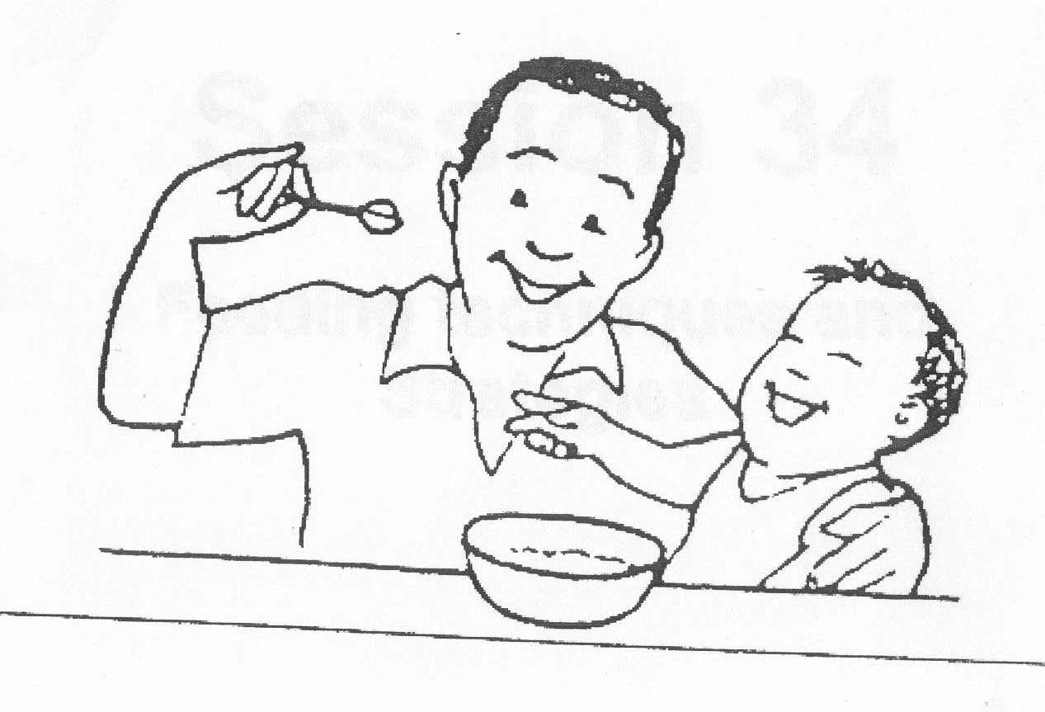

- Baby needs to be completely assisted in feeding till 1 year of age beyond which lesser and lesser assistance should be given in order to make the child gradually independent.
- Feed the child slowly and with encouragement according to the skills developed but never force feed.
- Offer variety of foods to suit child’s likes and dislikes.
- Avoid obstacles (e.g. television, gossiping with others) while feeding
- Promote child to eat by singing nursery rhymes and story telling.
- Success depends not only on what is fed but how, when and by whom

Eating with family during mealtimes encourages child to eat more than eating alone.

3. Care and recommendations while preparing complementary food
- Those who prepare, cook, feed the baby should wash hands thoroughly with soap and water (including baby’s hands).
- Serve food fresh. Cover leftover food and serve it as soon as possible
- Bottle feeding to be avoided since it is difficult to keep bottles clean and it increases risk of infection.
- It is essential to maintain good hygiene and cleanliness in and around the house. This requires ample supply of clean water and good sanitation. Lack of these facilities increases risk of infections especially diarrhoea after six months of age.
It has been observed that following all above instructions and guidelines (2 and 3) enhances appetite, growth and development.

4. Quantity of complementary food:
With increasing age the proportion of complementary foods should be gradually increased with corresponding decrease in breastfeeding frequency.

Age in  months | Calories from  Breastfeeding  % | Calories from Complementary  Foods % | Suggested frequency for offering complementary foods | Quantity
6-9 | 70 | 30 | 2-3 times; gradually with breakfast, lunch, dinner | Start with 2-3 spoonful and increase to ½ wati per feed
9-12 | 50 | 50 | 3-4 times: As above and once in between meals: more than half of caloric intake | ¾ wati to full wati
12-24 | 30 | 70 | 5 times or more: as above and twice in between meals | More than 1 wati as per child’s needs
- Snacks: Food items which are convenient and easy to prepare, offered in between two meals and usually self-fed e.g. fruits, laddus, porridge, chiwda etc.

5. Appropriate Food Consistency: Initially should be like ghee, gradually the consistency of food should become thicker.

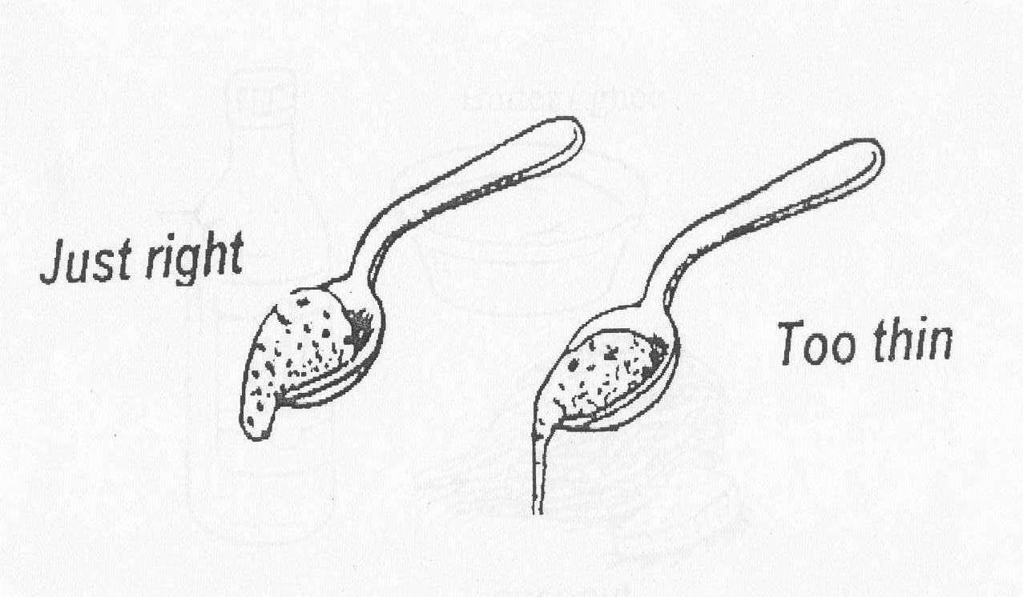

6. Foods to be included in the child’s Menu
- Home food is best
- Avoid tinned and ready to eat food
- Avoid making separate food preparations for the baby unless routine family food is excessively spicy
- Avoid watery dal, rice water, soups, juices which only have water and no calories
- Snacks should be used in between meals or if food is not ready
- Freshly cut and softened fruits. A spoon can be used to scrape the pulp. Fruits should be properly washed before cutting or peeling
- Curd with sugar and salt
- 3 parts rice and 1 part of dal washed, dried and ground to a coarse powder. This can be stored in a tin for 7-10 days. When necessary this powder can be roasted with ghee and can be cooked with water and/or milk (with sugar or salt) to make a porridge (kheer).
- Kheer: Prepared from rava, wheat and nachani flour
- Cereals, pulses, vegetables, fruits together constitute a balanced diet. Sprouts and fermented food have better nutritive value and give protection against infection.
- Some children like sweet dishes while some may like spicy food. Children should be fed to their liking. ‘Feeding sweet dishes and sweets lead to worm infestation’ is a myth.
- Non-vegetarian food can be introduced after 9 months
- Foods like biscuits, noodles, wafers, chocolates, aerated cold drinks, cakes, pastries and sauce should be avoided.
- Animal milk or formula cannot be a part of complementary feeding. It can be used to prepare curd or kheer or can be given with rice or roti. If necessary, after second birthday animal milk can be given in a limited quantity. However do not use bottle to feed milk. Children should not be forced to drink animal milk.

Special instructions on inclusion of foods in child’s menu :
- Ensure protein and iron rich foods are included in vegetarian diet such as pulses , green leafy vegetables.
- Vitamin A rich fruits and vegetables need to be consumed daily like papaya , mango
- Sufficient fats should be present in daily diet
- Nutrient poor drinks like tea, coffee and cold drink need to be avoided
- Avoid excessive use of fruit juices

7: Feeding a child during and after an illness
- A sick child normally prefers to breastfeed and tends to avoid eating food. Hence breastfeeding ensures that the sick child continues to get at least a part of the caloric and fluid requirement. However child should be encouraged to eat by offering soft, easily digestible and tasty foods in small quantities but more frequently During recovery child needs an extra meal per day for 15 days. This helps to regain the weight lost during an illness.
- Child should also be given enough water and fluid

8. Depending on local availability, foods containing following nutrients should be used while preparing complementary foods
Vitamin A: Carrots, Tomatoes, Drumstick leaves / pods, Beetroot, papaya, mango, leafy vegetables, milk and milk products, egg yolk and fish are rich in vitamin A.
Vitamin B: Green leafy vegetables, milk, whole grains, cashew nuts, almond are good sources of vitamin B. .
Vitamin C: All kinds of fruit-especially citrus fruits (lemons and oranges), oranges, amla, tomato, strawberry, leafy vegetables are rich sources of vitamin C. This vitamin is heat sensitive and hence gets destroyed while cooking. Hence fruits should not be pre-cooked e.g. Apple should be offered without prior steaming.
Vitamin D: After 4 months of age the baby should be exposed to sunlight. Vitamin D is formed in the skin on exposure to sunlight. All care should be taken to prevent sunburns and irritation to eyes. All exclusively breastfed babies need to be watched for signs of vitamin D deficiency. Mother’s milk also contains vitamin D. Hence as long as breastfeeding continues, the mother should take calcium and Vitamin D tablets (at least 6 months to a year) and get sunlight exposure morning \ evening.
Combining cereals and pulses: A mix of cereals and pulses in a proportion of 3:1, provides first class proteins. Thus traditional dishes like rice- moong dal ( ), idli-sambar, dosa –sambar may be given
Fats: Children need more fats in diet than grown-ups. Hence children should be given extra servings of oil/ghee or butter. If these sources are not available or affordable then, oil seeds ground-nuts, coconut, sesame, khaskhas, soyabean) should be used while preparing complementary food.
Iron: Though breastmilk contains less iron, it is more readily absorbed. Hence exclusive breastfeeding for 6 months meets the iron needs of the growing infant. Infant will not become anaemic if she has sufficient iron stores at birth (these in turn depends on mother’s body iron stores). Low Birth Weight babies (birth weight less than 2.5 kg) have deficient iron stores at birth and hence need iron supplements after 6 weeks of age.
Non-vegetarian foods, leafy vegetables, jaggery, dates, black currants are good sources of iron. Cooking food in iron utensils increases its iron content. Using lemon (vitamin C) increases the bioavailability of iron.

Counseling on infant feeding when child’s growth is faltering
Weight of the child should be taken every month and plotted on the Mother Child Protection Card. If the growth of the child dips in any month then ASHA / Anganwadi should understand the reason and counsel the mother/ family accordingly on correct complementary feeding practices. (as explained above)
The common reasons for growth faltering include
- Delayed introduction of complementary feeding
- Faulty complementary feeding (in quality , quantity , frequency)
- Illness and episodes of diarrhoea

